

DIIGITAL SIGNAL PROCESSING & COMMUNICATIONS

PDE2113 GROUP PROJECT REPORT

*8-QAM Software and Hardware Implementation*

*Group no.: 4*

*Members: Pavan Benjamin Philip(M01036984),*

*Karl Enzo Cruz (M01039769),*

*Adam Nosseir (M00972954)*

Lecturer: Mrs. Siona Carmel Menezes Picardo

***TABLE OF CONTENTS***

***HARDWARE IMPLEMENTATION***

***(MATLAB AND RASPBERRY PI)***

1. Introduction
2. Conceptual Understanding
   1. Digital Communication Systems
   2. *Vector Encoding*
   3. *8-QAM Modulation*
   4. Additive White Gaussian Noise (AWGN)
   5. Signal-to-Noise Ratio (SNR)
   6. Channel Attenuation (h)
   7. Demodulation
   8. Maximum Likelihood (ML) Detection
   9. Vector Decoding
3. System Overview
4. Hardware Implementation using Raspberry Pi  
    4.1 Raspberry Pi as a Hardware Noise Generator  
    4.2 Python AWGN Server Architecture  
    4.3 TCP Communication Protocol  
    4.4 Justification for Raspberry Pi Hardware Channel
5. System Workflow
   1. User Input and Configuration
   2. Digital Input and Vector Encoding
   3. Carrier Wave Modulation
   4. Raspberry Pi Channel
   5. The Raspberry Pi's Role (The AWGN Channel)
   6. Channel Attenuation
   7. Carrier Demodulation and Detection
   8. Maximum Likelihood
   9. Performance Analysis BER (Bit Error Rate)
   10. Data Visualization using plots
6. MATLAB → Raspberry Pi → MATLAB Communication Flow
7. Raspberry Pi and Python Setup
8. Hardware Implementation Challenges
9. Performance Evaluation
10. Results and Discussion
    1. Results
    2. Discussion
11. Conclusion
12. Future Improvements

**SOFTWARE IMPLEMENTATION (MATLAB)**

1. *Introduction*
2. *Background Theory* 
   1. Digital Communication Systems
   2. Fundamentals of QAM
   3. 8-QAM Symbol Mapping
   4. Symbol Energy Normalization
3. *MATLAB Transmitter Implementation* 
   1. *User Input and Bit Validation*
   2. *Timing Parameter Computation*
   3. *8-QAM Constellation Generation*
   4. *Bit to Symbol Mapping*
   5. *Carrier Modulation Process*
   6. *Transmitted Signal Output*
4. *AWGN Channel Simulation*
   1. *Purpose of the AWGN Model*
   2. *AWGN Equation*
   3. *SNR Control and Noise Level*
   4. *Noisy Constellation Visualization*
   5. *Importance of the AWGN Channel in the Project*
5. *MATLAB Transmitted and Noisy Constellations*
   1. *Ideal (Noise-Free) Constellation*
   2. *Modulated Waveform Inspection*
   3. *Effects OF AWGN on Constellations*
   4. *Summary of Findings*
6. Demodulation and ML (Maximum Likelihood) Detection
   1. *Demodulation*
   2. *Received noisy Symbols*
   3. *ML Detection Method*
   4. *Euclidean Distance Detection*
   5. *Symbol De-Mapping*
   6. *Bit Extraction*
   7. *Summary*
7. *BER Detection and Its Variations*
8. MATLAB Code Explanation
9. Results and Discussion
10. MATLAB and Hardware (MATLAB +Python using Raspberry Pi) Performance Analysis
    1. *Performance Analysis*
11. Conclusion
12. Reference
13. Personal Overview
    1. Pavan Benjamin Philip
    2. Karl Enzo Cruz
    3. Adam Nosseir
14. Appendix

**Contributions**

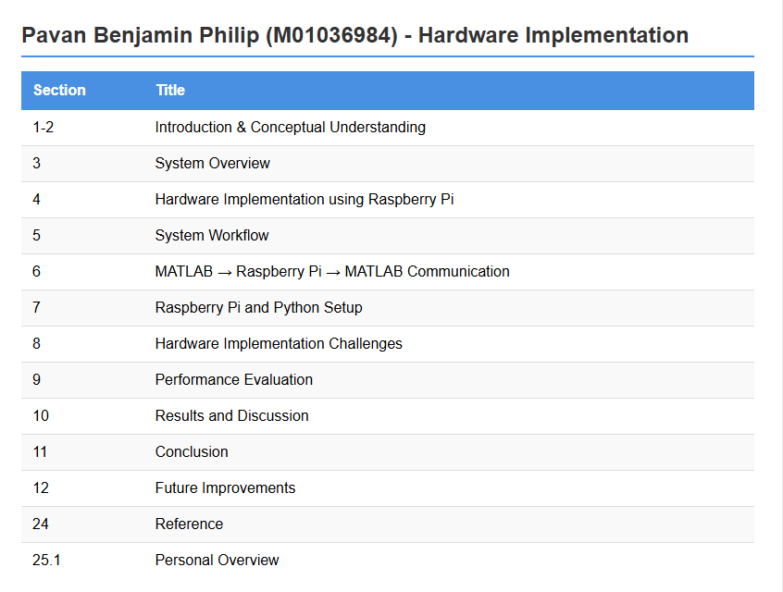

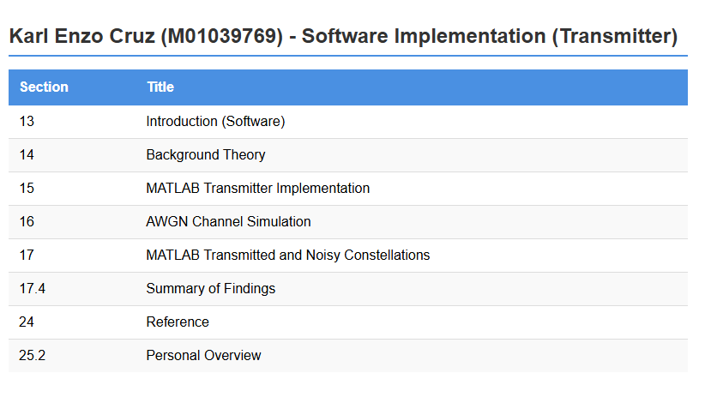

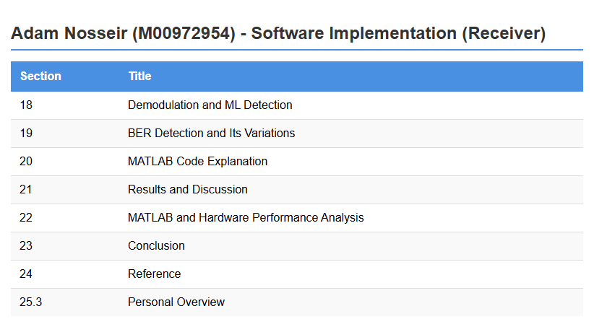

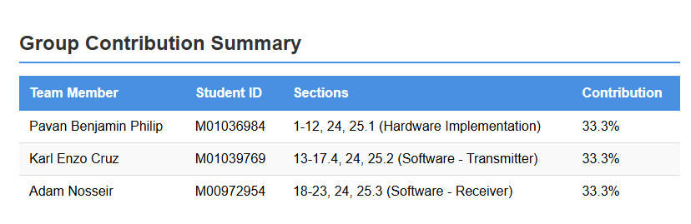

**Project Note**

## **As per each member’s understanding we have highlighted (bold font) the words and statements we felt were important towards easier understanding of the concept irrespective of the titles that are already using bold font.**

**Each member has highlighted (bold font) their parts and its contents separately.**

**As seemed best to display our understanding of the 8-QAM Communication System.**

**We have worked diligently and with lots of effort to showcase our understanding in a document.**

**Project Task**

* ***Use MATLAB to simulate a communication system which:***
* ***takes an input sequence of bits entered from the keyboard***
* ***performs vector encoding using 8 QAM constellation***
* ***modulates the encoded vector to generate the transmitted symbols***
* ***pass the transmitted symbols through AWGN communication channel***
* ***demodulates the received symbols***
* ***performs MAP/ML detection to retrieve the transmitted encoded vectors***
* ***decode the vectors to recover the transmitted sequence of bits.***
* ***You should plot the following:***
  + ***the transmitted 8 QAM constellation***
  + ***the transmitted symbol***
  + ***the received symbol***
  + ***the received 8 QAM constellation***

**Hardware (Using Raspberry Pi and MATLAB) and Software (MATLAB) Implementation of an 8-QAM Digital Communication System**

**HARDWARE IMPLEMENTATION (Using Raspberry Pi and MATLAB)**

1. **Introduction**

This project presents the **design and implementation of an 8-Quadrature Amplitude Modulation (8-QAM) digital communication system**, which uses **MATLAB** to input data from the user and then let it undergo modulation. The modulated data is then transferred to add the **Additive White Gaussian Noise (AWGN) channel** which is emulated in **hardware using Python in Raspberry Pi 5.** Since **MATLAB** is primarily designed for **x86-64 (Intel or AMD) Processors;**

A hybrid architecture was developed: **MATLAB** performs **bit generation, modulation, symbol mapping, attenuation, and Maximum Likelihood (ML) detection,** while **Python** running on **Raspberry Pi** implements the **AWGN noise generation channel** using **NumPy’s AWGN model.** **Data exchange** between **MATLAB** and **Raspberry Pi** is achieved via **TCP sockets** And by **encrypting it** using **SSH Protocol**, enabling **real-time symbol transfer.**

1. **Conceptual Understanding**
   1. **Digital Communication Systems**

A **digital communication system** converts **binary bits into analog symbols** for transmission through a **physical channel.** The channel Introduces **Discrepancies:**

* **Noise**
* **Interference**
* **Distortion (Natural Causes)**

**Receiver goals:**

* Correctly estimate the **transmitted symbols using ML Method**
* Calculate **Bit Error Rate (BER)** and **Attenuation** during the transmission.
  1. **VECTOR ENCODING**

In this part the **input sequence** that’s provided by the user gets **grouped as 3 bits per symbol.** These symbols are then **mapped to the Constellations.**

Example: 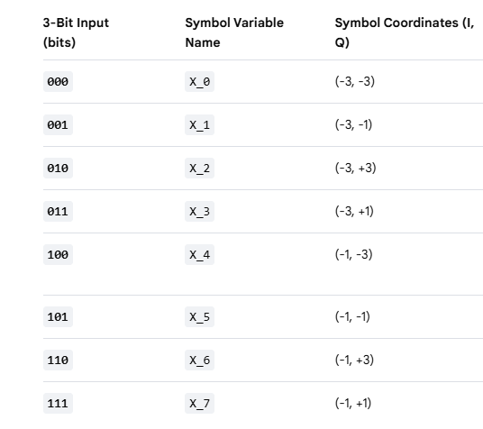

**Ideal Constellation used for the 8-QAM System**

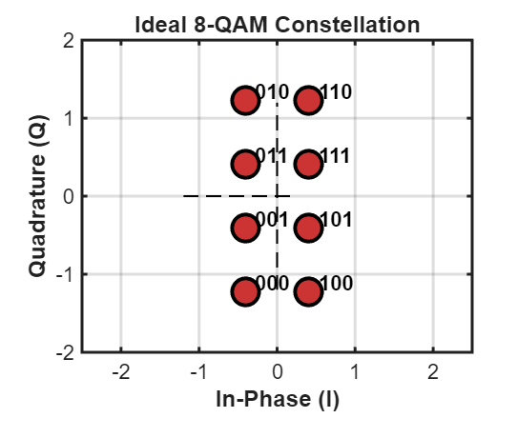

* 1. **8-QAM Modulation**

**Modulation** is basically a method for converting the input sequence into **symbols** and then mapping them to the **constellations** which is then passed to the **carrier wave** for **transmission.**

**Procedure**

8-QAM **maps 3 bits per symbol onto complex numbers**:

$$X=I+jQ$$

We represent the constellations using the formula

The constellation (given in MATLAB) used for our **8-QAM** is an 8-point rectangular arrangement normalized by **Es (Average Energy per Symbol).**

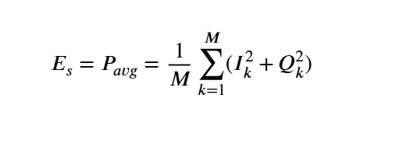

We **normalize constellations** to **standardize the power levels** of the signals we transmit. There are **limits** on **how much power transmitters** can use to **transmit signals** thus **normalization helps in standardizing this power gap.**

These Signals are then transmitted using the carrier signal waves that is given to us using the formula 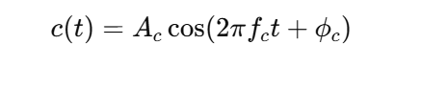

Since the modulation technique we are using is **QAM (Quadrature Amplitude Modulation),** we require both the **in-phase carrier** component and the **quadrature carrier** component 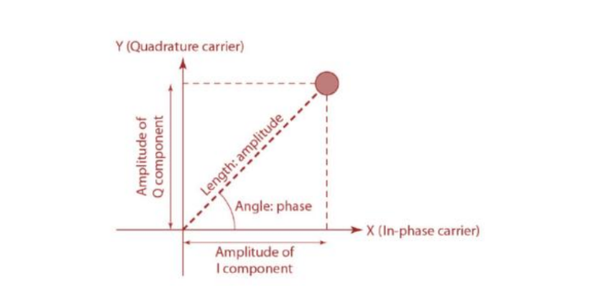

Therefore, by using this equation we are going to represent **the In-Phase and Q-carrier (Components):**

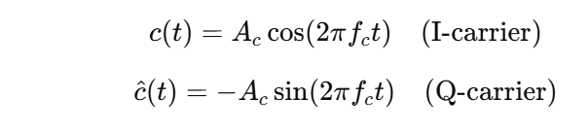

And the modulated **QAM Signal** becomes**:** 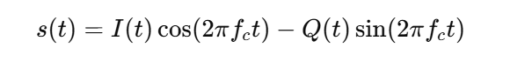

**Transmitted Symbols**

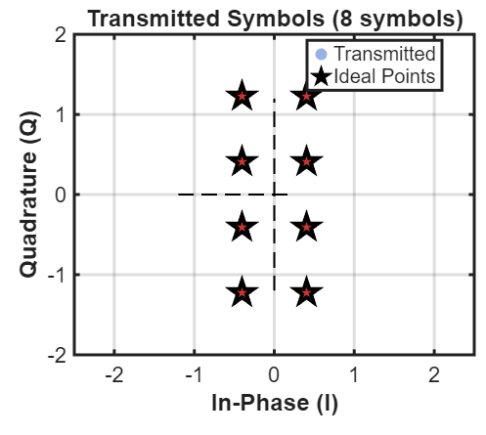

* 1. **Additive White Gaussian Noise (AWGN)**

**AWGN Signals** are **noise signal** which are **added to the transmitted signal** to test the **error handling capabilities** of the System. Basically, **AWGN channel i**ntroduces the **error,** and the **communication system** is designed to **overcome it.**

**AWGN** **adds statistically random noise** with:

* Constant power spectral density
* Gaussian amplitude distribution

*In* ***communication systems,*** *the* ***AWGN noise*** *follows a* ***Gaussian (normal) distribution.***

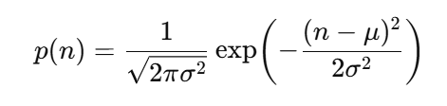

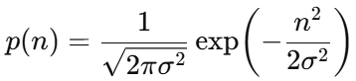In **Standard Distribution** **mean =0**

**Understanding AWGN (Additive White Gaussian Noise)**

* **Additive:** The noise is **additive**, meaning that it is **simply added (Linearly)** to the **transmitted signal.** The **received signal R(t)** is the **sum of the transmitted signal S(t)** and the **noise N(t):**

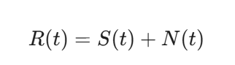

* **White:** **Power Spectral Density (PSD)**is **constant for all frequencies.** This means the **noise power is uniformly distributed.**
* **Gaussian:** Since the **noise is random** the received signal follows a **random continuous gaussian Waveform.**

***Uses***

* ***Performance Analysis*** *of Communication Systems*
* ***Channel Modeling*** *(Ideal Noise Channel)*
* *Receiver* ***Algorithm Testing***
* ***BER Curve*** *Generation*
* ***Noise Modeling*** *in Digital Signal Processing*
  1. **Signal-to-Noise Ratio (SNR)**

**SNR** basically **measures how strong the signal is compared to the noise**. It’s expressed in **decibels (dB)**. The equation for **SNR** is given by

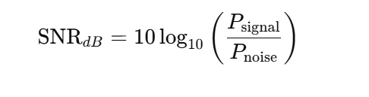

***Comparative Understanding***

* **Higher** the **SNR** → **Cleaner** the **Signal**
* **Lower** the **SNR** → **Noisier** the **Signal**

***Uses***

* **Helps in Analyzing the:**
  + **BER** (bit error rate)
  + **Accuracy** of our **signal** **transmission**
  + Clarity of our **Constellations**
  + **Varying** communication ranges
  + Performance of our **modulation**
  1. **Channel Attenuation (**h**)**

**Attenuation** is basically the measure of how much **signal strength** has been **reducing** as it **travels through a channel** (Because of **various unwanted interferences and Transmission range**).

It is given by the equation

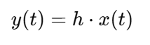

where **y(t) [received signal]** is given as the product of **x(t) [transmitted signal] and h [attenuation factor].**

The **lower the attenuation**, **stronger the signal becomes** thereby minimizing the **Errors**.

* 1. **Demodulation**

***Received Symbols***

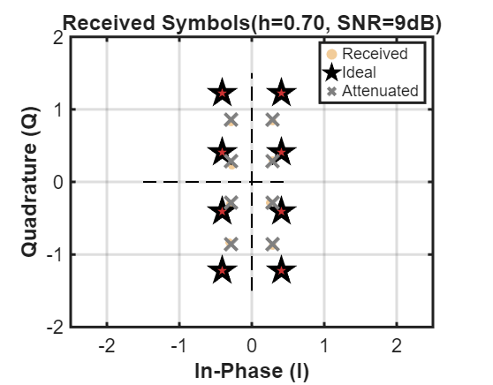

It is basically the **exact opposite of Modulation.** That is, it recovers the **Original Symbols (I and Q)** from the **received modulated signal.** The received signal is given using the equation

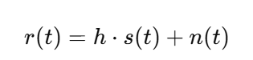

**Demodulation** basically uses **Matched Filtering Method** to recover the original symbol.

***In-Phase Component***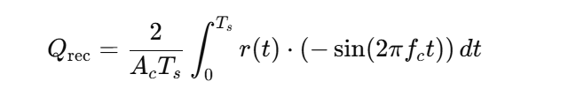

* **Multiply** by **cosine carrier**
* **Integrate** over the **symbol period**
* **Normalize** by $A_{c}$ **and $T_{s}$**

**Quadrature Component**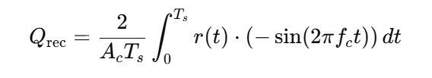

* Multiply by **(-sine carrier)**
* **Integrate** over the **symbol period**
* **Normalize** by $A_{c}$ **and $T_{s}$** 
  1. **Maximum Likelihood (ML) Detection**

Since the symbols we receive after **demodulation are corrupted with unwanted** noise, it will **spread out most** likely around the **original constellation point (I, Q)** so we will have to map the **received symbol back to the original constellation.**

When its **spread out** too much away from the **original constellation** that’s when **Errors occur.**

So in-order to get the **Original Transmitted Symbol**; **ML detection** picks the **constellation point** that is **closest to the received (I, Q) point.**

The AWGN noise spreads the received point around the **original constellation point.**The closest point has the **highest probability** of being the original Transmitted Symbol.

The Equation for **ML (Maximum Likelihood)** is given by **

where $r=(x,y)$**=> received symbol** and $c_{k}=(I_{k},Q_{k})$**=> constellation point $k$**

Therefore, the **Received symbols** are mapped Back to the **original constellation** by calculating the **minimum distance** from each constellations. The **original constellation** is the **closest one from the symbol**.

***Detected Constellations***

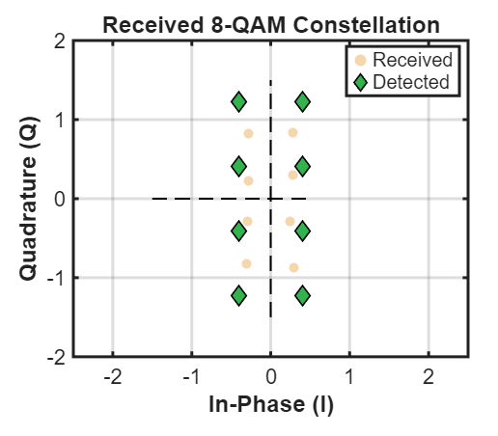

* 1. **Vector Decoding**

**Vector Decoding** is the final stage in the **digital communication system** where the detected **8-QAM symbols** are then converted to their corresponding binary values.

This process is basically the **exact opposite of vector encoding.**

1. **System Overview**

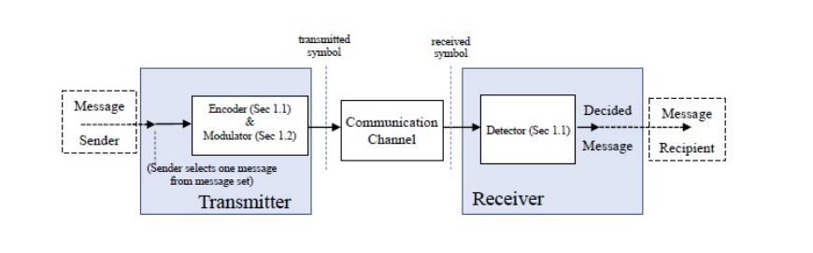

This project basically implements **a complete 8-QAM digital communication system** that operates using both **MATLAB Software and Python using Raspberry Pi 5 hardware** in a continuous **sequential setup.** The system demonstrates how digital information is **encoded, modulated, transmitted through a noisy channel (AWGN), and accurately recovered using ML (Minimum Likelihood/Minimum Distance) detection.** The process includes both **software-based signal processing** and a **hardware-assisted AWGN channel** which is implemented on the **Raspberry Pi using python**.

The system begins with an **input from the user (information)** which is to be transmitted through the system. the input data is then passed through the **vector encoding process** where the individual bits are **grouped to 3-bit vectors.** The vectors are grouped in such a manner that their **decimal equivalent is from 0-7.** This conversion simplifies the **selection of corresponding constellation points** and helps us in creating a **structured mapping format** between **modulated symbols** and its **corresponding constellations.**

Next, the **encoded sequence** is passed to the **8-QAM modulation block.** Each **encoded sequence** is **mapped to a predefined constellation point** consisting of an **In-phase (I) and Quadrature (Q) component.** These components represent the transmitted symbols. Since these symbols that are transmitted have **various energy levels**, they are **normalized by dividing them** with the **square root of Es (Average Energy per Symbol).**

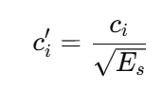

After modulation is done, the symbols are transmitted from **MATLAB to the Raspberry Pi 5 (Python) via a TCP/IP socket and SSH connection.** The Raspberry Pi operates as a **real-time hardware AWGN channel emulator.** As the **python server** receives the **modulated symbols,** the **AWGN noise** is added to the **original symbols** using the **SNR value** received from the user.

The **noisy symbols** are then **returned to MATLAB** where the **original symbols** are then **recovered** using the **ML (Maximum Likelihood) method.**

1. **HARDWARE IMPLEMENTATION USING MATLAB AND RASPBERRY PI 5**
   1. ***Raspberry Pi 5 as a Hardware Noise Generator***

The **Raspberry Pi 5** acts as an **independent processing node** that injects **Random Gaussian noise** into **transmitted symbols as per Python Code Instructions.** MATLAB transmits **encoded and modulated 8-QAM symbols** over a **Secure Shell (SSH)** **Socket** connection to the **Raspberry Pi.** The **Pi uses NumPy library** to generate **Additive White Gaussian Noise (AWGN)** according to a **specified SNR value** using the **equation.** The **NumPy Library** can handle **high-performance hardware signal-processing** with **lesser delays.**

* 1. ***Python AWGN Server Architecture***

The **Python server** that runs on the **Raspberry Pi 5** forms the core of the **Python AWGN** channel **Architecture.** The main role of the **python server** is to **install** the **Additive White Gaussian Noise (AWGN)** and return the **noisy symbols** back to **host machine (MATLAB) .**

* 1. ***TCP Communication Protocol****.*

The system uses a **request–response TCP protocol.** For a **TCP connection** a **dedicated connection** must be established, therefore here **MATLAB** acts as a **client**, while **Raspberry Pi runs the server.** It is the most reliable communication protocol between **MATLAB and Python.**

**Python Socket Library** binds the **HOST IP ADDRESS** to the **PORT Number** that is **python** basically listens for incoming **connections.**

* 1. ***Justification for Raspberry Pi 5 Hardware Channel***

The **Raspberry Pi 5** is used as a **independent signal processing medium** for injecting the **Additive White Gaussian Noise (AWGN).** The main purpose of the **Raspberry Pi 5 hardware channel** is to add the **AWGN signals** so as to **simulate a real-life signal transmission process.**

This will give us a **deepened understanding** on how **real-life signal transmission** occurs.

1. **System Workflow (Code Explanation)**
   1. **User Input and Configuration**

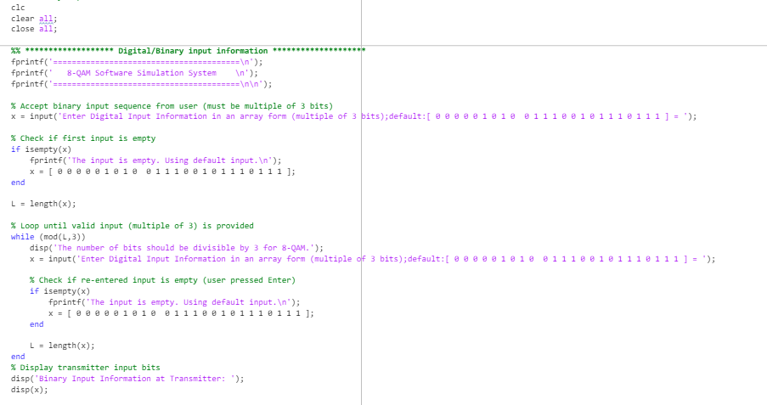

* The **initial line of our code** creates **a link** between the **Host (MATLAB) and Python (Raspberry Pi 5).**
* **PI_IP represents** the **IP address** of our **Raspberry Pi 5**.
* **PI_Port** is set as **5000** since that is the port which is used for **temporary user connection for specific tasks.** Also, **Port 5000 accepts connections from all interfaces** thereby **increasing** the **chance of a successful connection.**
* The user is requested to **input the bit sequence (Data that needs to be transmitted)**, **SNR value** and **Attenuation factor for processing;** **Default values are assigned** if the user leaves the input Dialogue box empty.
* Here the **default value** of **SNR,** that is **9dB (decibels)** was calculated by conducting **tests using trial and error method.**
  1. ***Digital Input and Vector Encoding***

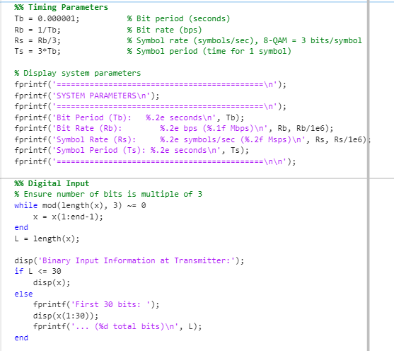

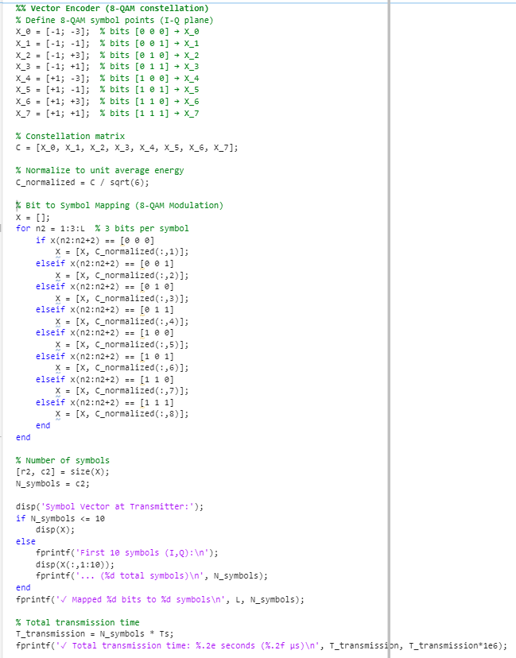

* **Timing Parameters** represent the **Bit Period, Bit Rate,** **Symbol period and Symbol Rate.**
* **Bit Rate is the no. of bit transmitted per second.**
* **Bit Period** is the **time taken per bit.**
* **Symbol period** is the **time taken per symbol.**
* **Symbol rate** is **no. of symbols in 1 second**.
* At this stage the input messages go through a process of being **grouped (3-bits in each group) into their decimal equivalents (0-7).**
* Before Mapping the constellations are **normalized using Es (Average Energy Per Symbol).**

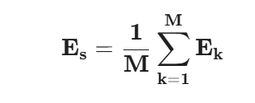

Given that

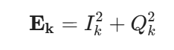

* These **3-Bit groups** are then mapped to their **respective constellations** using the **Gray Coding Method**.
* **Gray coding** is a method of **assigning bit sequences** to the **points** on a **constellation diagram (used in QAM and PSK)** such that the **bit patterns** of **adjacent constellation points differ by only one bit.** By doing so we can minimize the **BER (Bit Error Rate)** and **aliasing**.
  1. ***Carrier Wave Modulation***

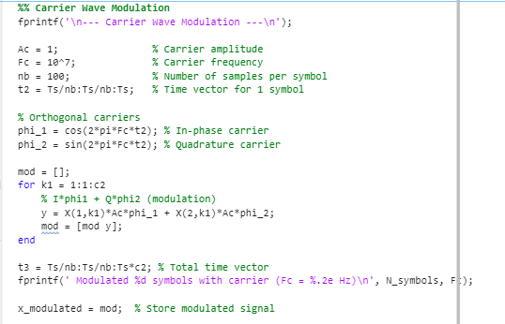

* **High Frequency carrier signals** are used to transfer data across the channel or medium.
* Our **modulated data** is transferred using the **high frequency carrier** which uses **2 orthogonal basis functions** to carry the **I (In-Phase) and Q (Quadrature) components.**
* **Orthogonality basis function** refers to **2 continuous carrier waves** that are **totally independent of each other.**
* Transferring is done in the code by **iterating through the symbols and concatenating the carrier waveform (mod = [mod y]).** Each **symbol duration** is **sampled nb=100** times to create a **smooth waveform.**
  1. ***Raspberry Pi Channel***

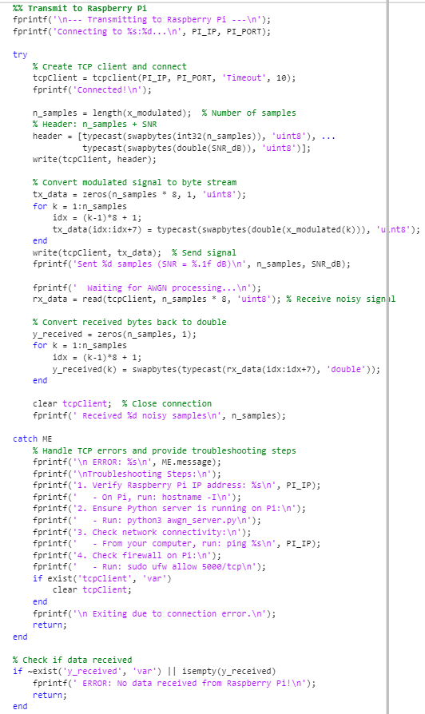

* Here a **connection** between the **MATLAB** and the **Raspberry pi** is established using **TCP/IP protocols.**
* **Connection** is established using **tcpclient(PI_IP, PI_PORT, 'Timeout', 10);**
* **MATLAB establishes** a **connection with Raspberry pi** **via WI-FI using its IP Address. A ssh (Secure Shell) connection (in command prompt)** is also established to secure the connection.
* The **entire** **x_modulated** **carrier waves**, **SNR** and **n_symbols** are **sent to Raspberry Pi.**
* After **AWGN is added in python** we will receive the **noisy symbols** back which will be **stored in the variable** **y_received**
* **Error handling** has also been set so that we can **understand** where the issue might be **if any errors have occurred during transmission.**
* There is also an **if statement** for confirming that we have received the **noisy symbols** back**.**

* The role of the python server (Raspberry Pi 5) here is to receive the **carrier waves** and then add **Additive White Gaussian Noise (AWGN).**
* In Python we are using the **library socket** to establish the link to **the host (MATLAB).**
* Using the **SNR value,** we will find the **noise variance** since the **Signal Power Es (Average Energy Per Symbol)** was **ensured by normalization.**
* **Noise variance** is calculated using the Formula Below: 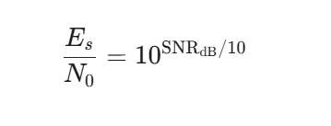
* Substituting

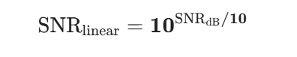

* We get

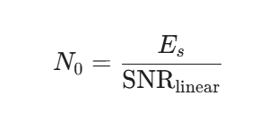

* Now we have to find the **Noise Standard Deviation**

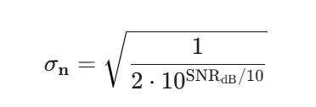

* Using the **Noise Standard Deviation** for **I and Q component** we are going to find the **real AWGN Noise(w)** using the equation given below

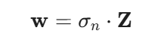

**Note: Z** is the **random gaussian values** with **variance=1** and **mean=0**

* Now we add this **noise vector** to the **Transmitted Modulated Symbol**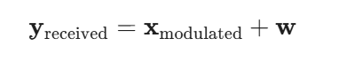
* After this our Signal is transmitted back to our **host server (MATLAB)**
  1. **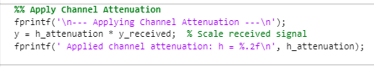*Channel Attenuation***
* Attenuation is basically the measure of **how much the signal strength has decreased** as it flows through the channel. **the attenuation factor ranges from 0-1.**
* The equation used to calculate the **attenuation in the system** is

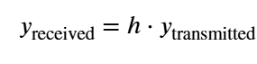

* 1. 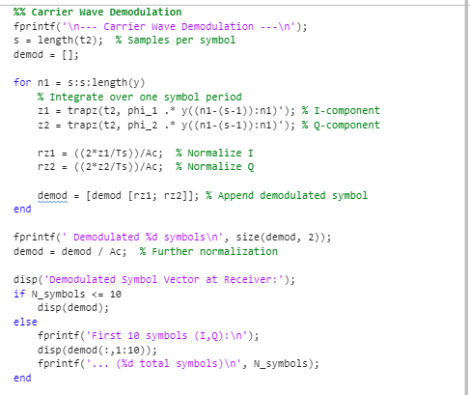**Carrier Demodulation and Detection**
* What we do here is the **inverse of modulation**, using the **same orthogonal basis functions (ϕ1​, Φ2​ )** to **recover the I and Q coordinates of each symbol.**
* To achieve the same, we use the **Trapezoidal Rule (*trapz*)** in the code. Basically, **matched filtering (correlation)** is done here to get the **I and Q coordinates.**
* The ***trapz* function** is used for **integrating the orthogonal basis functions** to get the **integral over each symbol period**.
* By **normalizing the integral** we can get the **I and Q coordinates.**
  1. **Maximum Likelihood**

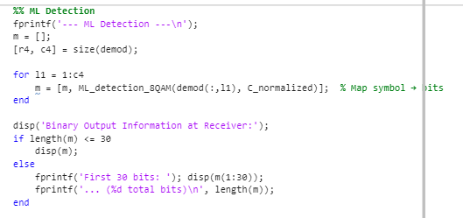

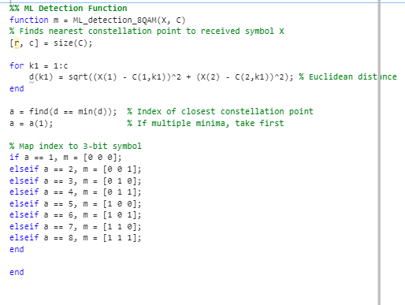

* A **new function named ML_detection_8QAM** has been made to calculatethe **minimum distance (also known as the Euclidean Distance)** of the **noisy symbols** from the **constellations.**
* The constellation from which the **noisy symbol** has the **least distance** is considered and the **noisy symbol is mapped back to it.**
* Therefore, the **noisy symbol is mapped back to the constellation which is of least distance from it.**
* **Maximum likelihood (ML) method** has been adopted because of the fact that these **noisy symbols are spread around the constellations** andsince the **closest constellations have the most probability of being the original constellation**, ML method is considered a great way to **receive the transmitted data.** 
  1. **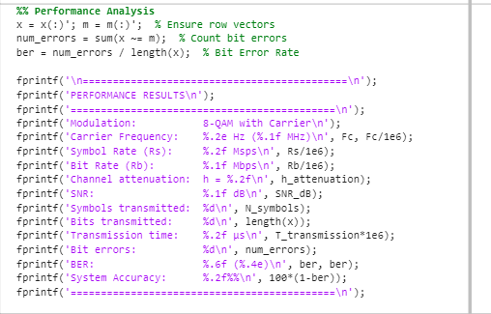*Performance Analysis* BER (Bit Error Rate)**
* Here we are calculating the **bit error rate (BER).**
* 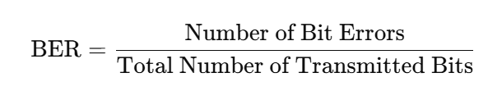BER is calculated using the formula
* This helps us understand the **efficiency of our System.** Through this we can further **deepen our thoughts** in **understanding** on **how to make data transmission the most reliable form of data transfer over the internet.**
* The performance of system is also displayed so that we can **assess our data transfer.**
  1. ***Data Visualization using plots***

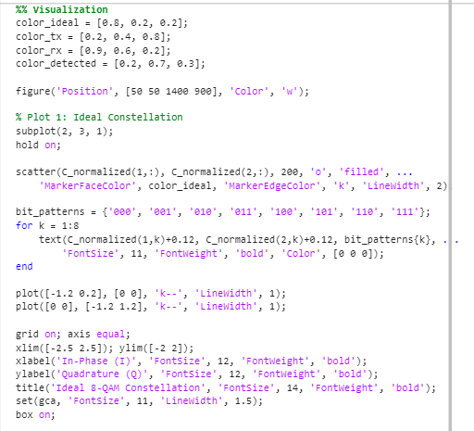

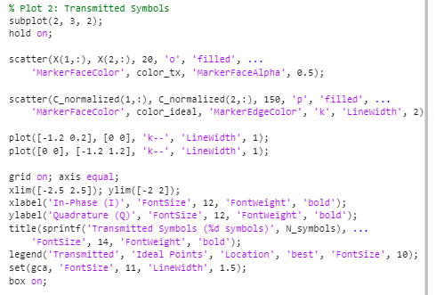

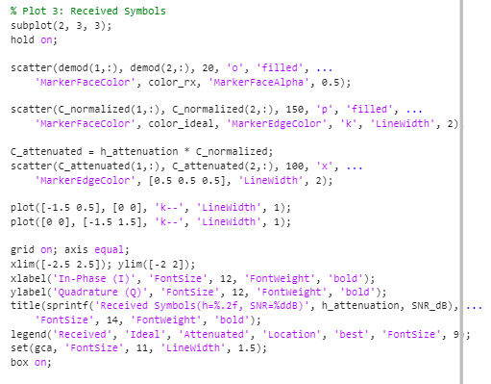

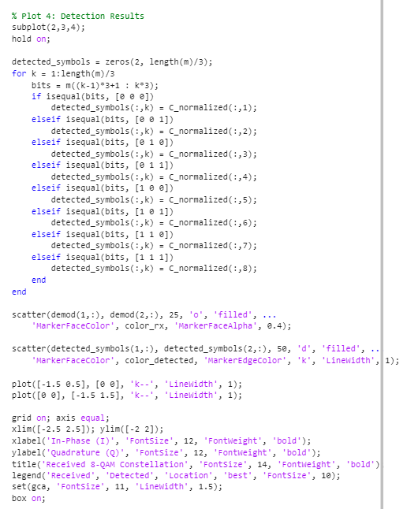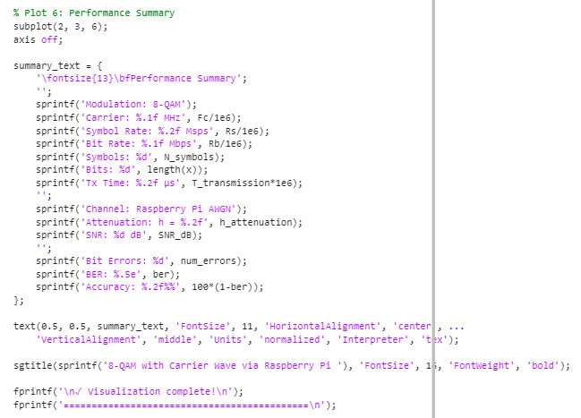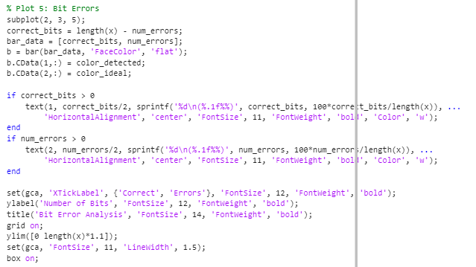

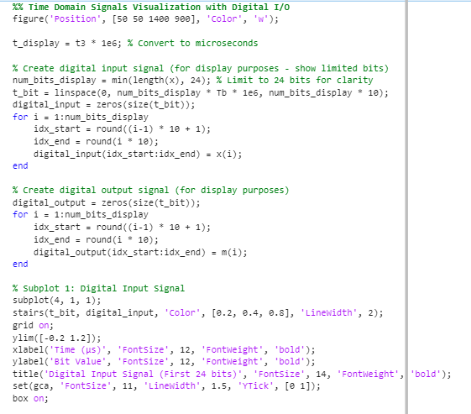

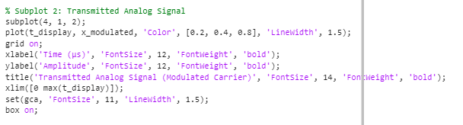

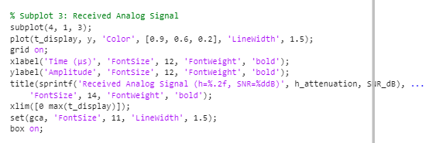

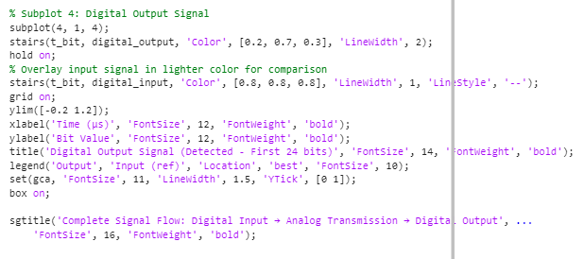

* Here we are **plotting the Final Required graphs for the question.**
* Visualization can help us get a **deeper picture on the Data transmission simulation.**
* We are also plotting **digital** and **analog input and output signals.**
* It will help us get a better idea on **how the transmission went** thereby giving us a **chance to make the transmission more perfect.**
* With the help of these **graphs,** we can also **test out the transmission** at different conditions, like by varying the **Attenuation factor or SNR.**

1. **MATLAB → Raspberry Pi → MATLAB Communication Flow**

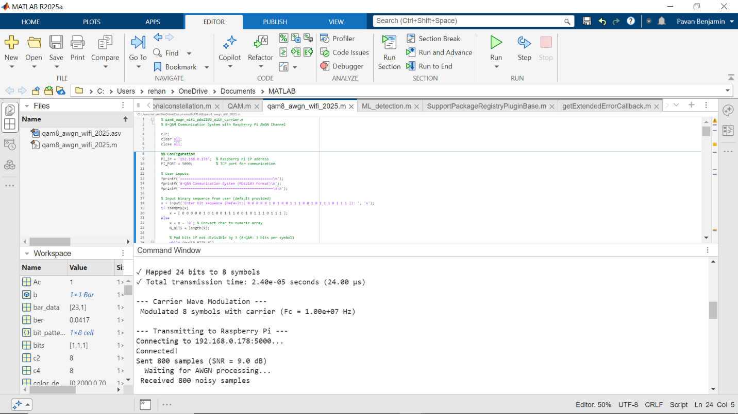Host Connection (MATLAB)

Secure Shell Connection (Command Prompt)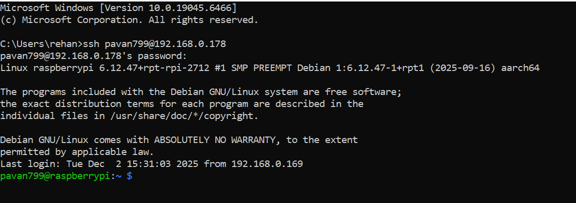

Raspberry Pi Connection (Python)

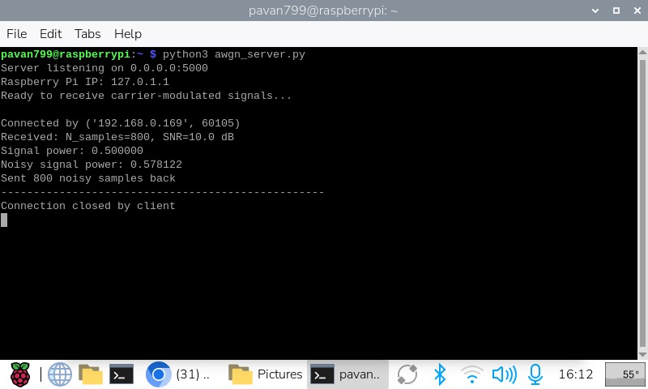

Inference

* From above pasted images we can see that **MATLAB has established a connection with the Raspberry PI (Python).**
* AWGN was added to **800 samples (In accordance with the Nyquist Sampling Theorem)** and was sent back to the **host (MATLAB)** .
* **Nyquist Rule (The sampling rate must be at least twice the speed of the fastest part of the signal)**

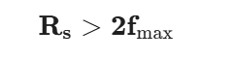

* **Data transmission was successful** and **final output** was returned from MATLAB (The plots pasted above)

1. **Raspberry PI AND Python Setup**

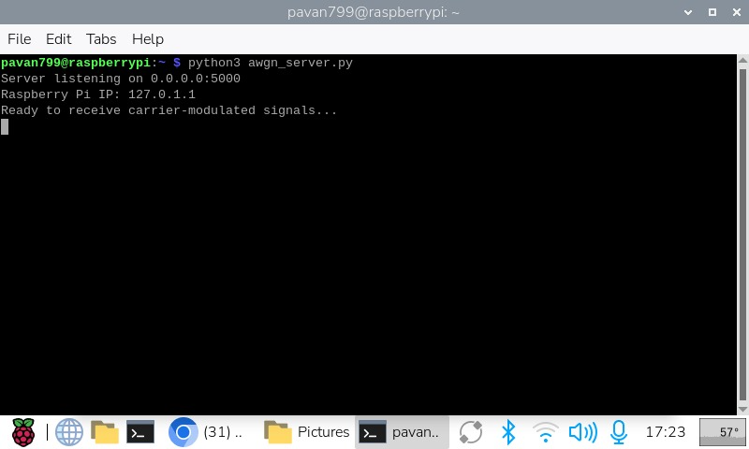

* Here we are initializing the **python server connection to the Internet.**
* Now the **Raspberry pi 5 (Python)** is ready to receive the data for **AWGN Implementation.**
* The command python3 awgn_server.py calls the interpreter python3 to run the awgn_server.py file.
* Now **AWGN** implementation can be done.

1. ***Hardware Implementation Challenges***

* First **Raspberry Pi 5 OS** wasn’t running So the **Raspberry Pi** would simply blink.
  + **Solution:** **Reinstalled OS**
* Due to **loose connection** of **led screen from raspberry pi**, the screen was **differently colored.**
  + **Solution:** **Reconnected wiring**
* I got confused with why my **BER (Bit Error Rate)** was **increasing** when I **decreased** the **Attenuation factor (i.e. <0.7)** since when **Attenuation** is **decreased, signal loss decreases** and **Accuracy increases.** 
  + **Solution:** **I understood that Attenuation is the logarithmic form of   
    the Attenuation factor so when the Attenuation factor decreases the accuracy of the system decreases and vice-versa.**
* The **Major Challenge** I faced was the **connection between raspberry pi 5** and the **Host (MATLAB).**
  + **Solution:** **Used SSH (Secure Shell) protocol for a secure connection.**

1. **Performance Evaluation**

* Since we are dealing with **Digital Signals**, there can be **errors during the transferring process** due to the **channeling medium.**
* In our **Digital Signal Communication Simulation,** we input **SNR (Signal to Noise Ratio)** for **AWGN (Additive White Gaussian Noise)** implementation. We also must input the **Attenuation factor** as well for **measuring** the **negative changes,** that is **path loss** in the **signal during transmission.**
* By **varying those values**, we will be able to understand **how data transmission varies.**
* By **evaluating and methodically analyzing** our system we will be able to make changes in-order to improve our **system** (**like reducing time-lag**).

## **Results and Discussion**

* 1. **Results**
* **Bit Sequence, SNR value and Attenuation Factor** were inputted by the user.
* The number of **Digital Input bits is checked whether it is a multiple of 3 to form a symbol**.
* The Individual **3 bit-grouped sequence** is then **mapped to the Constellations** to form **symbols [Vector Encoding].**
* As per the **Nyquist Sampling Theorem (The sampling rate must be at least twice as much as the max. frequency of the carrier signal)**.
* These symbols **(Baseband Signals)** are then loaded into **Carrier waves (High Frequency waves)** for **wireless transmission (Passband Signals:** Contains **2 basis functions** depicting the **cosine and sin components) [Carrier Wave Modulation].**
* Transmission to **python in Raspberry Pi 5 for AWGN (Additive White Gaussian Noise) implementation.**
* **AWGN Implementation** in **Raspberry pi 5** using **python** is done by using **Scaled random Gaussian Samples (Depends on the SNR value) [Adding AWGN].**
* The **noisy symbols** are then returned to the **host (MATLAB).**
* Apply **Attenuation** to depict **real time Data Transmission.**
* The **Carrier Wave** with the **noisy symbols** are sent back after **AWGN** has been added. The **Noisy symbols** are **extracted from them** using **integration and then normalizing them (using Matched Filters) .[Carrier Wave Demodulation]**
* **ML (Maximum Likelihood) Detection** is performed to **remap the received symbols back to their Original Constellations.**
* A clear **Diagrammatic Representation** and **Performance Analysis**  is **performed [Visualization/Plotting].**

***ORIGINAL OUTPUT (100% Accuracy)***

* For our **default values** the output **varies** between **100%** and **lower Accuracy**.
* By doing so we were able to realize the **apt point** at which the **System begins** to **transmit data perfectly.**
* We found these **apt values (default values)** through **trial-and-error** method. That is, we kept **0.7** as the **constant Attenuation value** and then tested the outputs for **various SNR values.**
* And then we were able to find out that at **SNR=10dB**; Our **System varies between 100% Accuracy and lower.**
* The output below is when **we got 100% Accuracy** with the **default values**.
* ***NOTE:*** These **default values** are taken when the **input is not provided** (just press **Enter** to use **default values**)

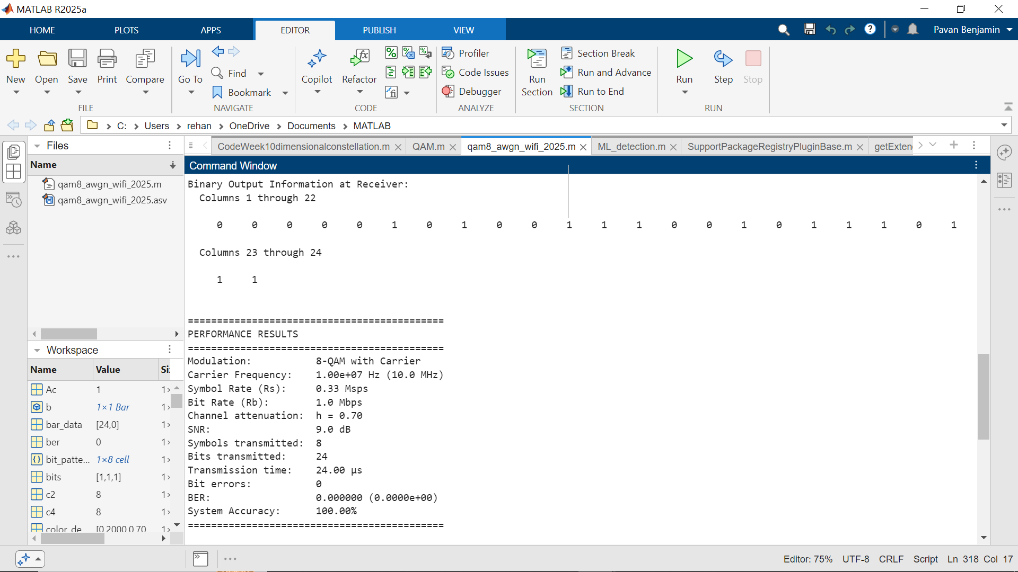

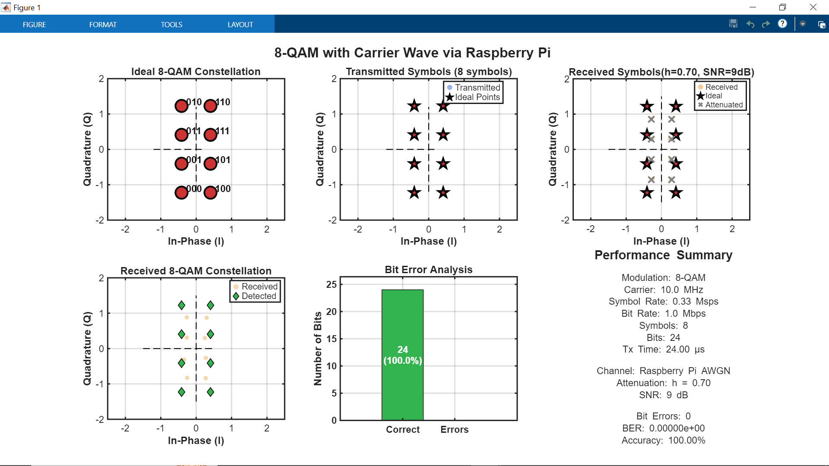

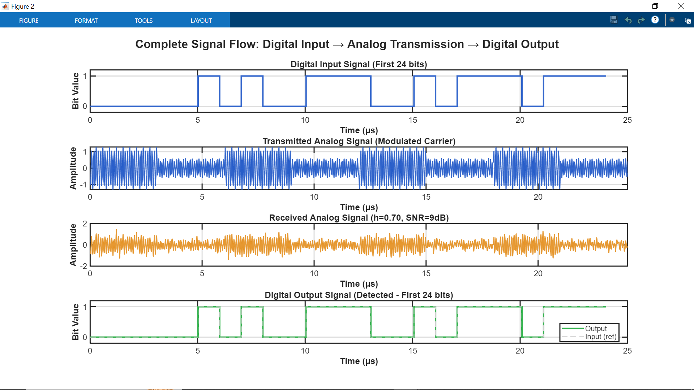

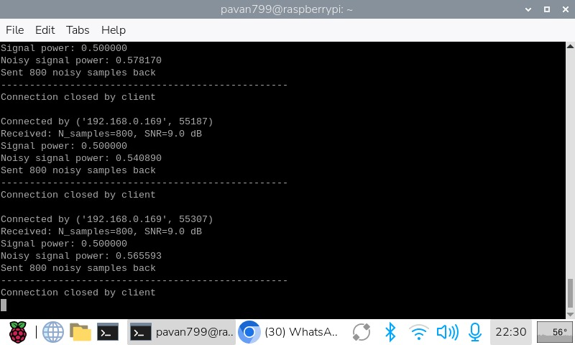

* The above image is from the **Raspberry Pi** which **receives** the **symbols**, adds **AWGN** and **transmits** the **noisy symbols** back to **MATLAB** (host)
  1. ***Discussion***

**Testing out the variations in the signal when SNR and Attenuation is changed**

**ORIGINAL OUTPUT (Lower Accuracy)**

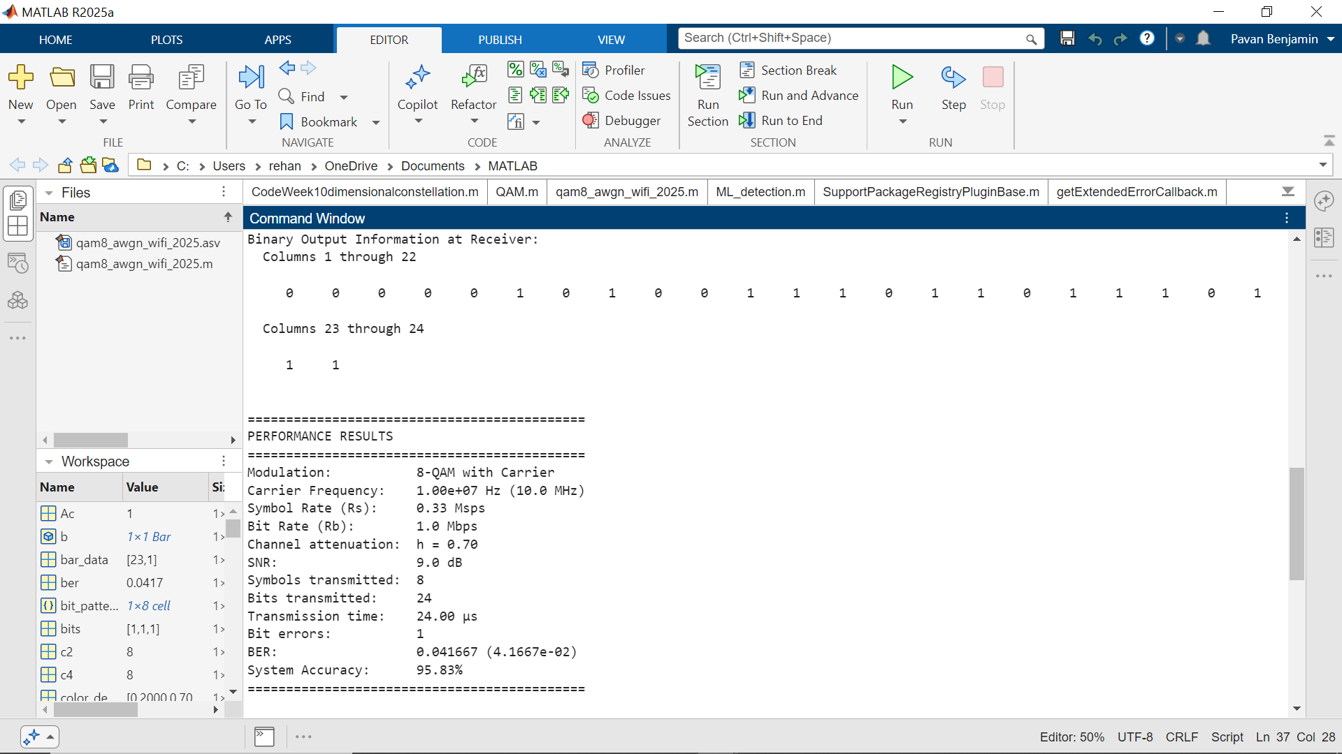

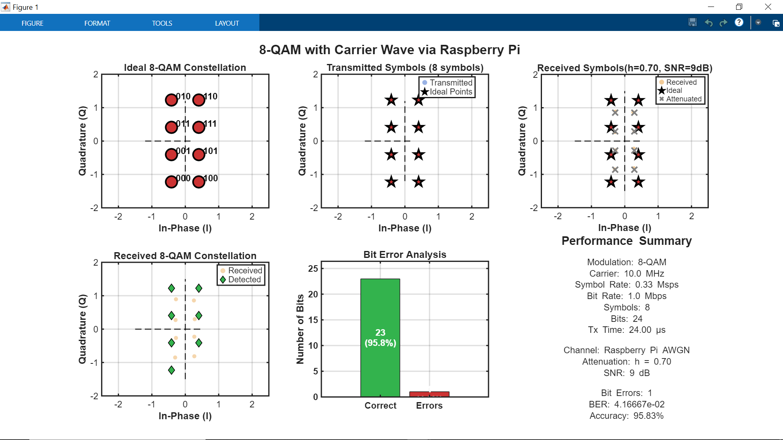

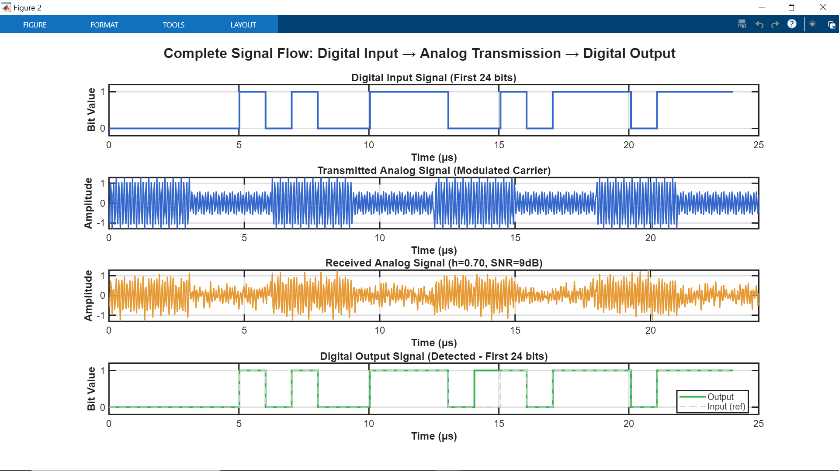

**SNR Increased**

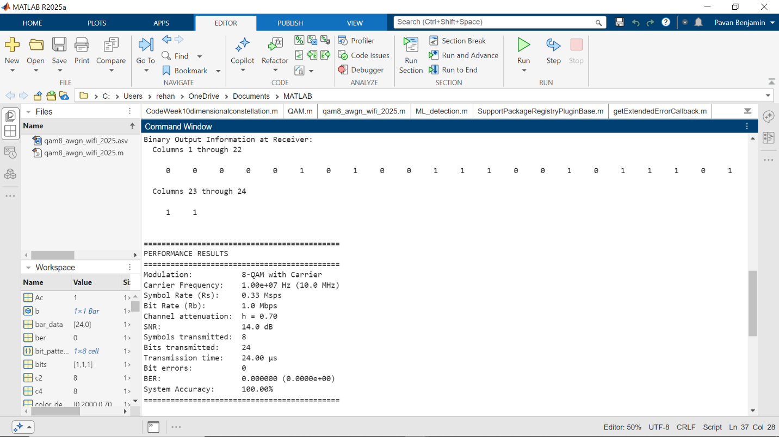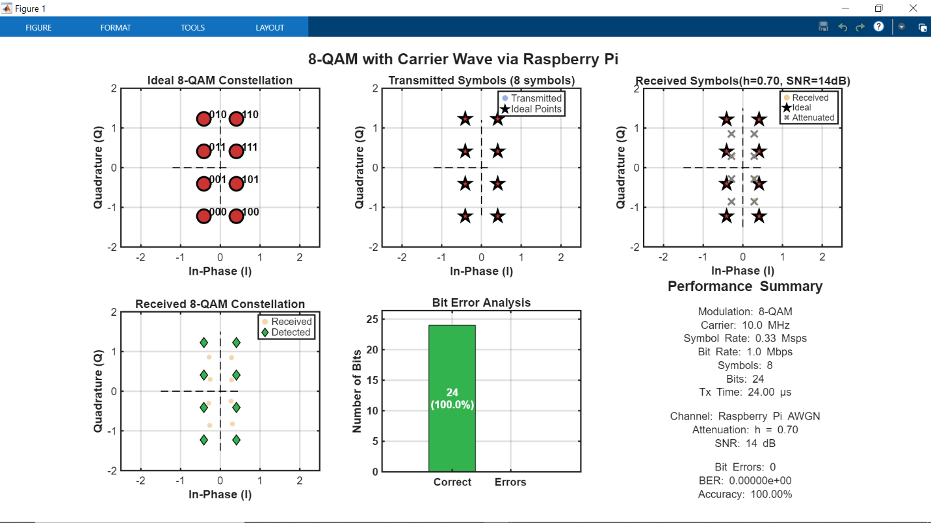

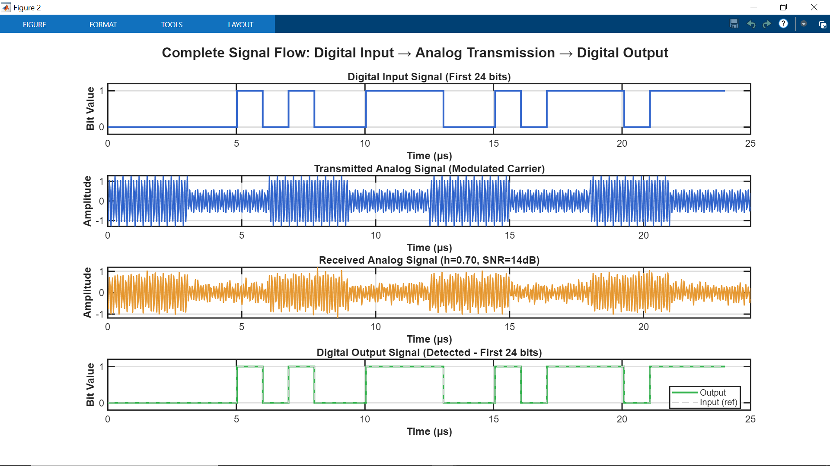

## **SNR Decreased**

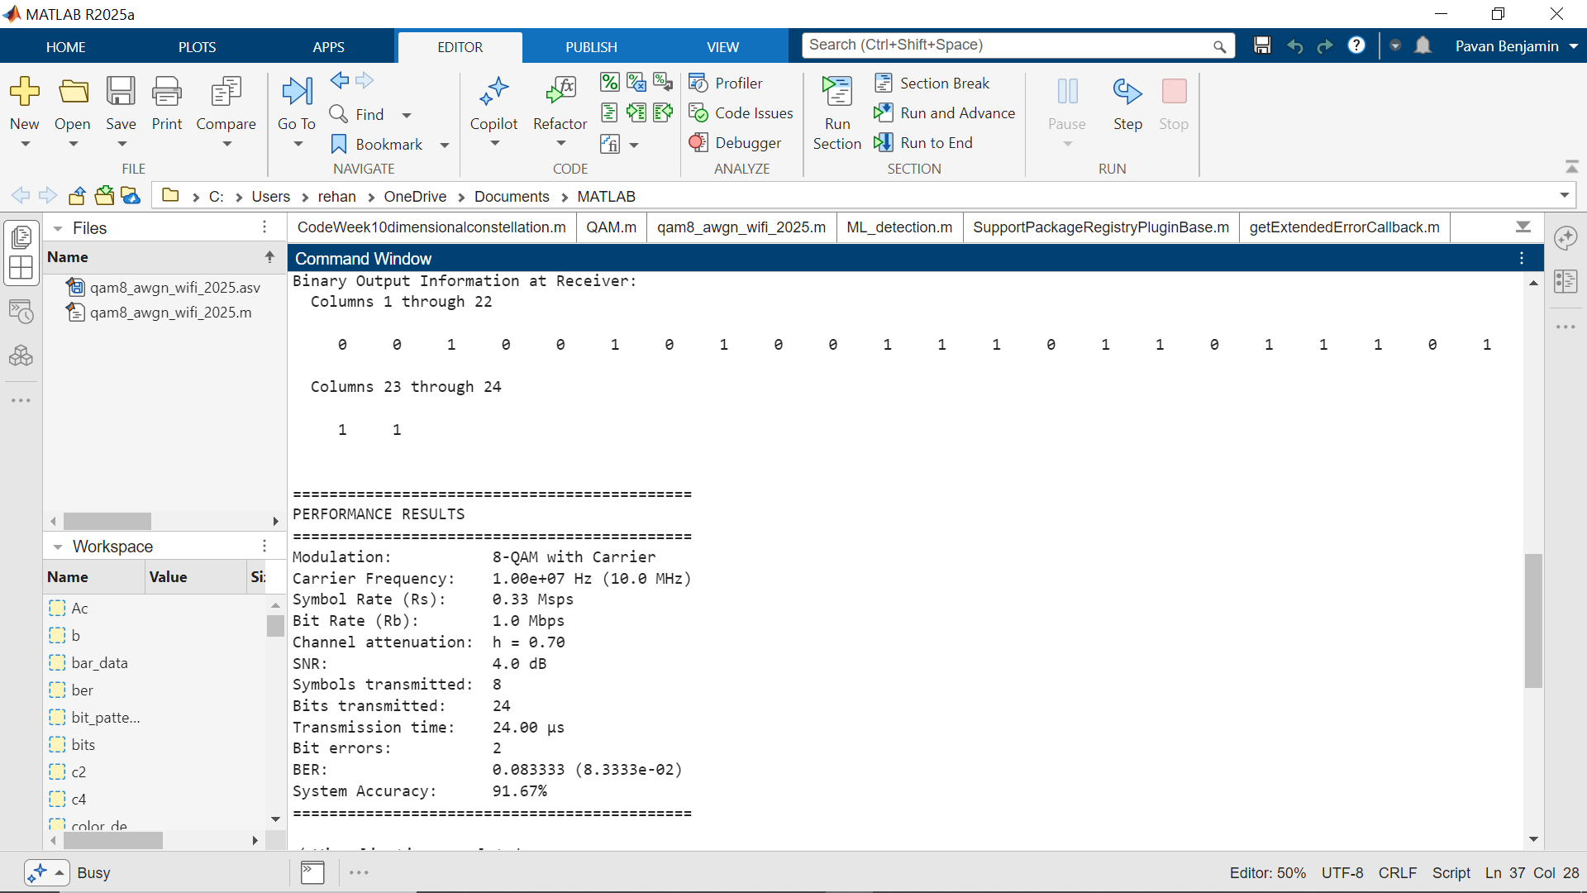

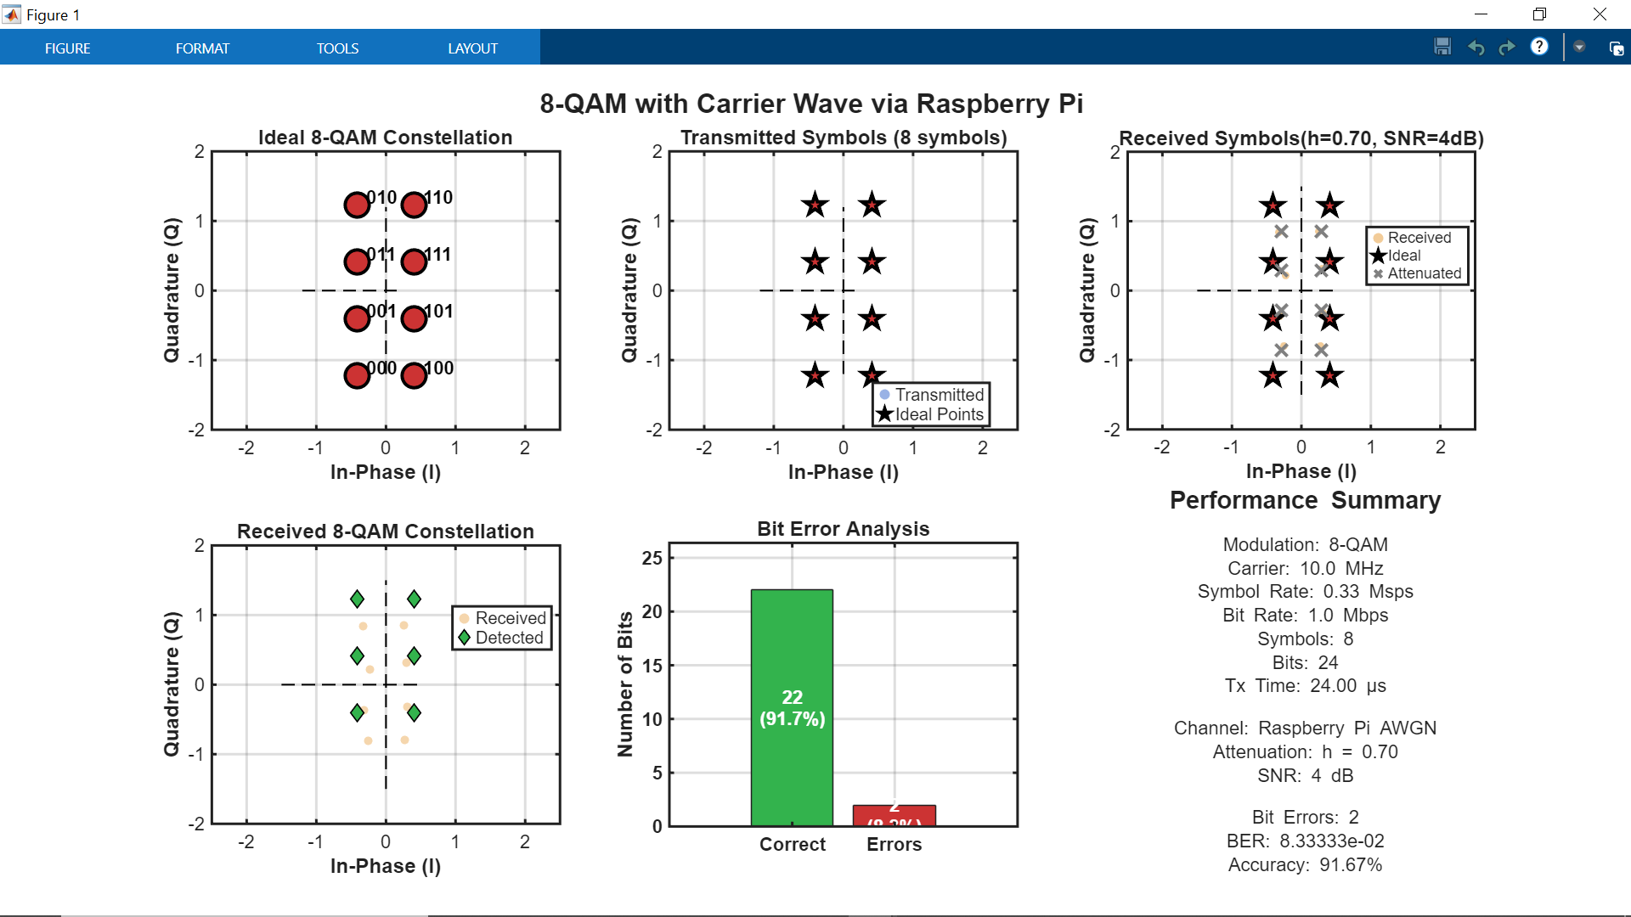

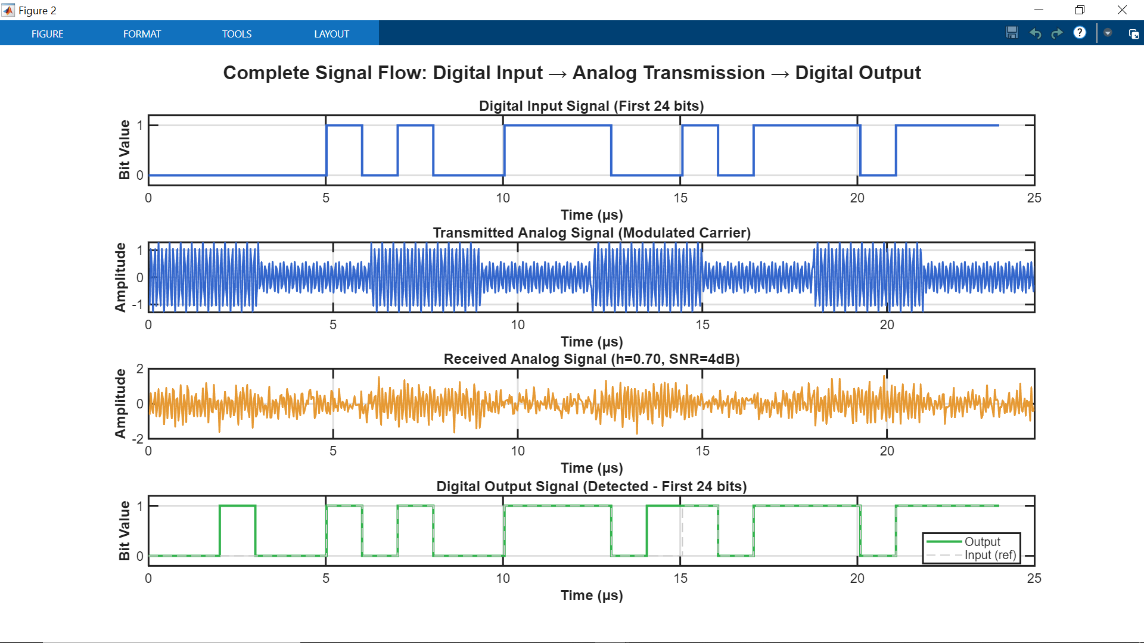

* By varying the **SNR values,** we can see that the **BER (Bit Error Rate) changes.**
* **As the SNR value increases, The BER (Bit Error Rate) Decreases and vice versa (i.e. as the SNR value decreases the BER Increases).**

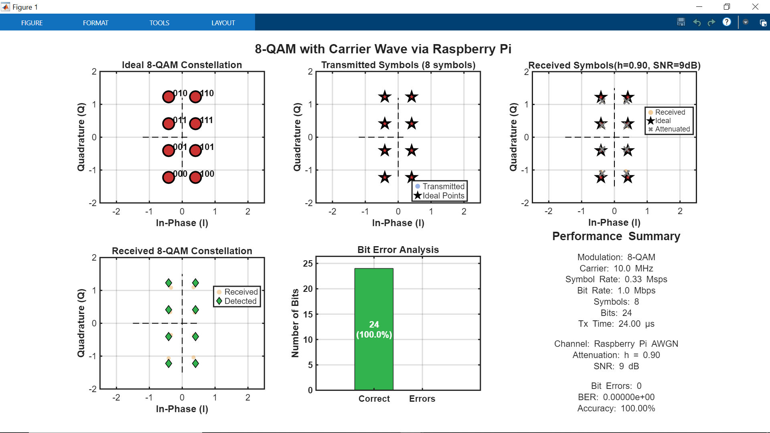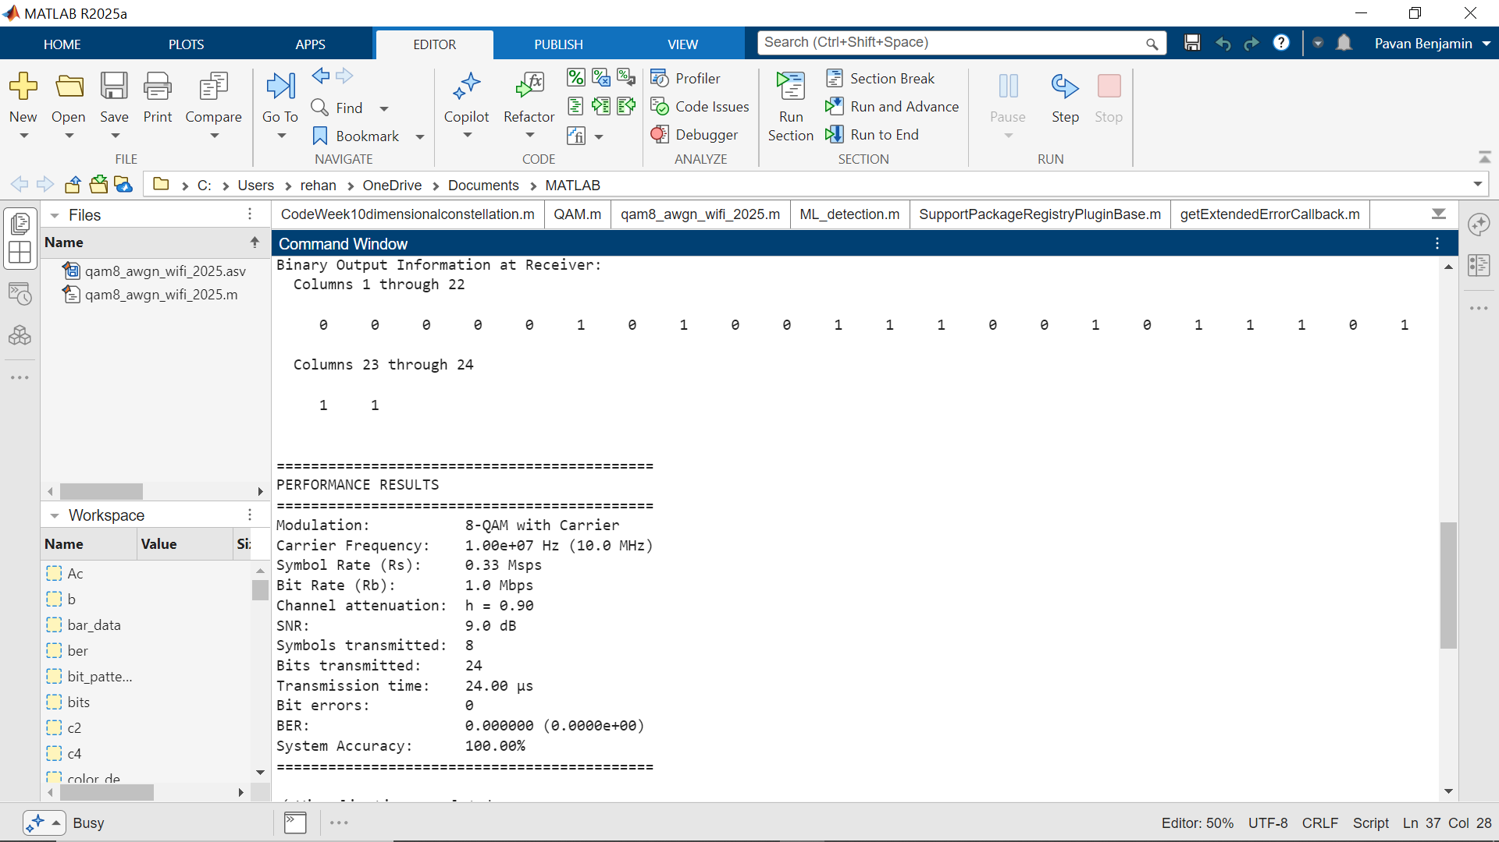**Attenuation Factor Increased**

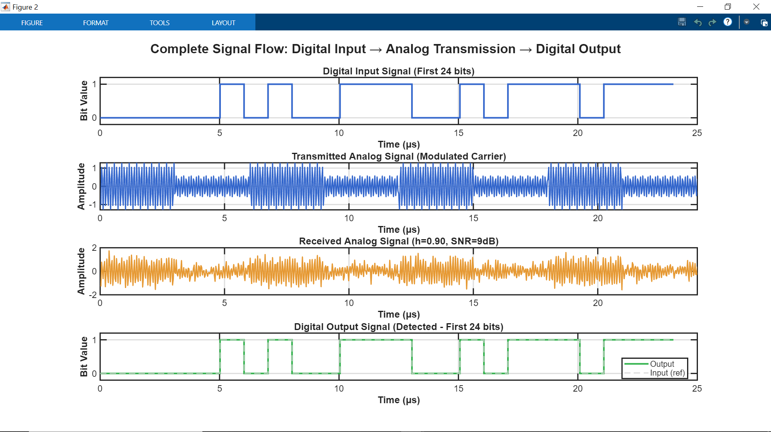

**Attenuation Factor Decreased**

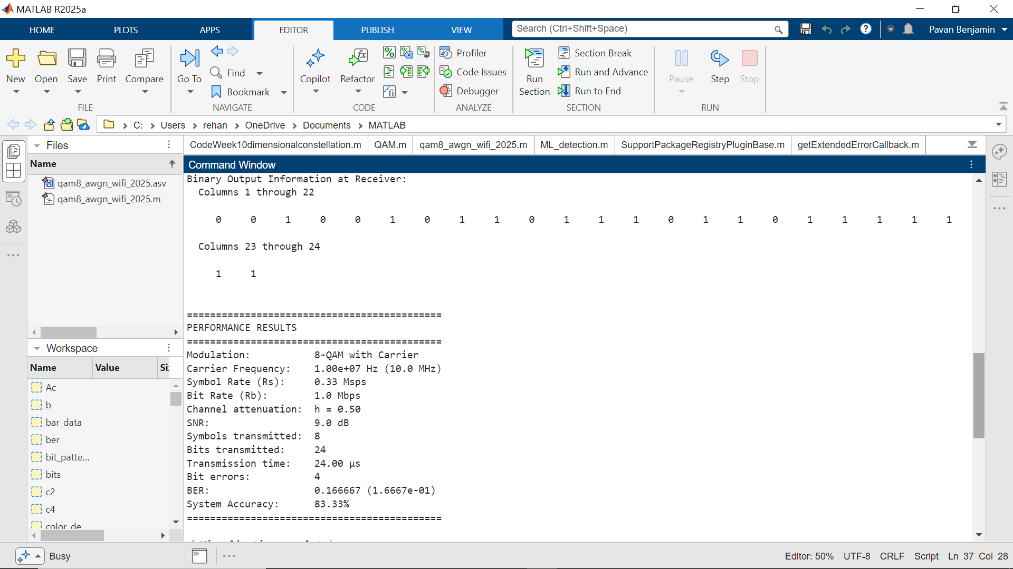

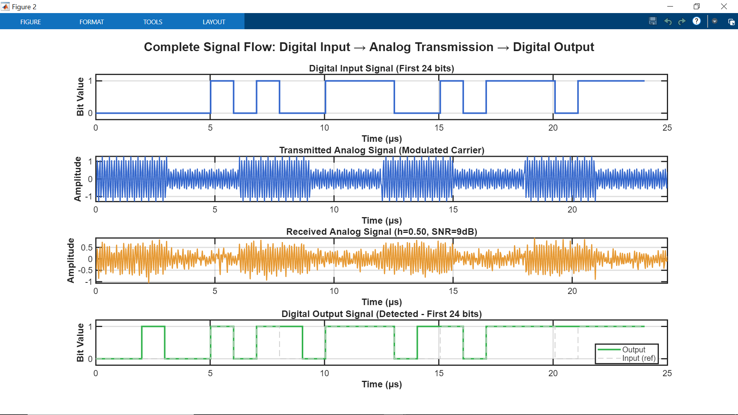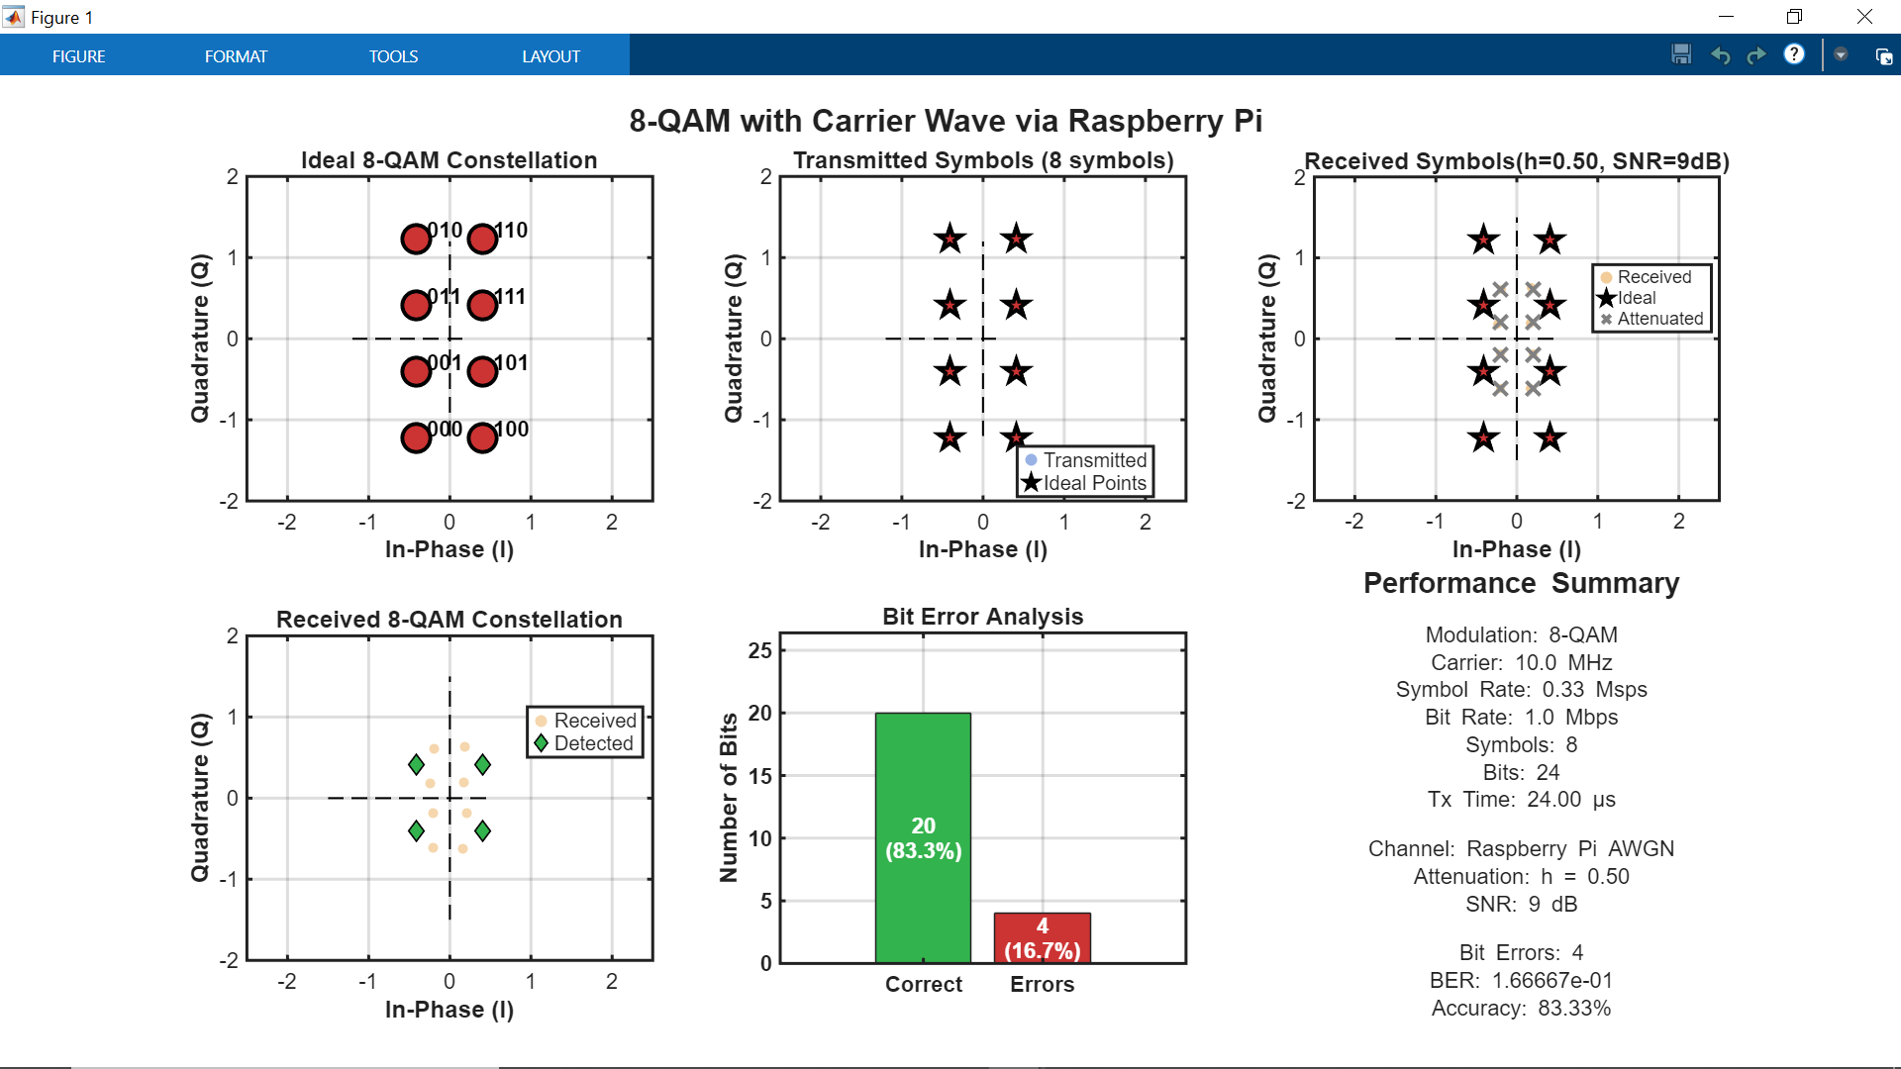

* By Varying **the Attenuation factor values** we can see that the **BER (Bit Error Rate)** changes.
* As the **Attenuation Factor (h) decreases, BER Increases** and therefore **Accuracy plummets. Vice versa** for the case when **Attenuation factor Increases (i.e. when Attenuation factor Increases, BER Decreases and therefore Accuracy increases).**

1. **Conclusion**

The **hardware implementation of the 8-QAM System** was **successfully handled** and **performed to meet the required results.** The **system was implemented** using a combination of **MATLAB (for Vector Encoding, Modulation, Demodulation and ML Detection)** and **Raspberry Pi** for **real-time hardware transmission** and **processing (AWGN Implementation).** **Each input bit sequence** was **mapped to the constellations** and **modulated onto the orthogonal carrier waves**, producing a **passband signal.** **The system took 100 samples** according to the **Nyquist Sampling Theorem**, ensuring **accurate representation of the 10 MHz carrier frequency.**

The **transmitted signal** was then passed through an **Additive White Gaussian Noise (AWGN) channel** that was **implemented using Python on the Raspberry Pi.** This simulation **simulates a real-time noise Interference** so as to get an idea on how these **interferences** might **affect the signal.** The receiver **demodulated** the **noisy signal** using **correlation (Matched Filtering)** with the **carrier wave basis functions** and performed **Maximum-Likelihood (ML) Detection** to recover the **transmitted Symbols.**

Overall, the **8-QAM System** that been **implemented** above gives us the basic idea of how **data transmission** occurs over the **Network**. This gives us a better figure of how the **System can be improved in the Future for better Results.**

1. **Future Improvements**

In the current **8-QAM setup**, the **Baseband Symbols** are **modulated** **directly onto the carrier** and **sent through the channel.** But sometimes there could be issues with the input since the input signal could be of **less quality** which could cause **disruptions during Transmission.**

**Improvement:** A **matched filter (Pulse shaping)** could be used on the **input signal** before it **undergoes transmission.** This can make the **input data** **clearer** so that the **transmission occurs smoothly** and the **probability** that **ML Detection** can detect the **symbols increases.**

***SOFTWARE IMPLEMENTATION (MATLAB Only)***

1. ***Introduction***

This section focuses on the **transmission** side of an **8-QAM communication system** modelled entirely in **MATLAB**. This project includes **bit grouping**, **vector encoding** using the **8-QAM constellation**, **symbol normalization**, **carrier modulation**, and **visualization** of the **transmitted** and **noisy constellation points**. The goal is to generate a clean **8-QAM signal** and observe how the channel affects it when **Additive White Gaussian Noise (AWGN)** is introduced.

**Digital Communication** requires careful conversion between binary data and analog waveforms. The mapping between bits and **8-QAM constellation** points determines how the information can be recovered later. In **MATLAB**, this process includes designing the **constellation**, **normalizing symbol energy**, and **modulating** the **symbols** on **orthogonal carries**. Noise modelling plays a crucial role since every real communication channel introduces **random fluctuations**.

This section also provides a structured explanation of the **theoretical concepts** behind **digital modulation**, the **fundamentals of QAM**, **symbol energy normalization**, and the mechanisms of **carrier wave generation**. It also includes the **MATLAB** **implementation** and explains each component of the transmitter code. Lastly, it presents and interprets the **required plots**: **the clean 8-QAM constellation, the transmitted waveform, the noisy waveform**, and **the received constellation under Additive White Gaussian Noise.**

1. **BACKGROUND THEORY**
   1. ***Digital Communication Systems***

*A* ***digital communication system*** *converts* ***binary data*** *into a form that can be* ***transmitted over a physical medium*** *such as* ***air, coaxial cable, fiber optics, or wired electrical channels.*** *The basic flow is:*

***[Transmitter] -> [Channel] -> [Receiver]***

* ***Source Encoding***
  + *The original message is converted into binary data.*
* **Channel Encoding**
  + *The bitstream may be given* ***redundancy for error detection/correction.***
  + ***Channel Encoding*** *is about adding* ***redundancy*** *to protect the signal* ***against errors*** *in transmission*
* **Modulation**
  + *Bits are* ***mapped to the Constellations*** *that* ***modulate*** *a* ***sinusoidal carrier.***
* **Channel**
  + *The signal is affected by* ***various impairments****:*
    - ***AWGN***
    - ***Attenuation***
    - ***Interference***
    - ***Fading***
* **Demodulation and Detection**
* *The receiver extracts the* ***I/Q components*** *from the* ***sinusoidal carrier*** *and estimates the* ***transmitted symbol****.*
* *Estimation is done using* ***ML (Maximum Likelihood) Detection***

***Digital modulation*** *is necessary because* ***raw binary signals*** *are unable to travel* ***long distances*** *or* ***through high frequency radio channels.*** *A* ***carrier sinusoid*** *lifts the information to* ***higher frequencies,*** *making* ***wireless transmission possible.*** *By* ***combining amplitude*** *and* ***phase variations****,* ***QAM*** *achieves* ***high capacity*** *without requiring* ***additional bandwidth.***

* 1. ***Fundamentals of QAM***

***Quadrature Amplitude Modulation*** *is a modulation technique that transmits information* ***using two orthogonal carriers****:*

* *An* ***In-phase component*** *represented by a cosine wave*
* *A* ***Quadrature component*** *represented by a sine wave*

*These carriers are orthogonal because:*

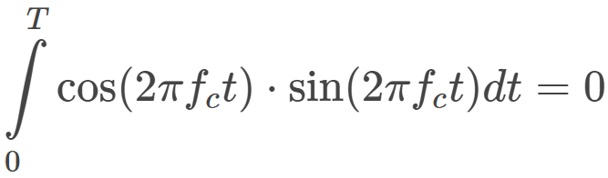

*This allows* ***two independent streams of data*** *to be sent* ***simultaneously*** *using the* ***same frequency without interfering****. This way Data can be transferred* ***without any Interference****.*

*A QAM symbol is represented as:*



*Every point in the I-Q plane corresponds to a* ***unique symbol.***

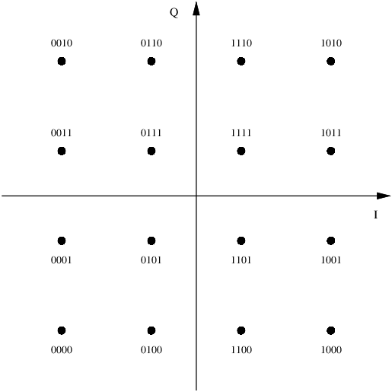

* 1. ***8-QAM Symbol Mapping***
* *In* ***8-QAM****, each symbol represents* ***three bits****:*
* ***3 bits per symbol -> 8 distinct positions (constellations)***
* *During* ***modulation****, the* ***bits are grouped*** *and* ***assigned to constellation*** *points. In* ***MATLAB****, these points are represented as* ***2D coordinates, (I, Q).***
* *Because* ***8-QAM*** *has fewer points than higher level programs such as* ***16-QAM or 64-QAM****, the spacing between points is larger, leading to a* ***lower probability of error.***
* *The mapping used in our project is as an* ***asymmetric square-like constellation****,* ***optimized*** *for* ***balancing average symbol energy (Es).***

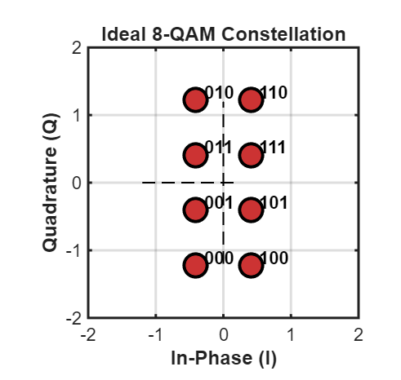

* 1. ***Symbol Energy & Normalization***

***Different constellation******shapes*** *have* ***different energy distributions.******Normalizing*** *ensures that the* ***average transmitted energy*** *is* ***constant****, which is required for* ***consistent SNR calculations.***

*Let the constellation points be denoted as:*

$X_{k}=\left(I_{k}, Q_{k}\right)$*The average energy is:*

$$E_{S}=\frac{1}{8}\sum_{k=1}^{8}{\left(I_{k}^{2}+Q_{k}^{2}\right)}$$

***Normalization*** *is performed by* ***dividing each point by: $\sqrt{E_{s}}$***

*This* ***standardizes*** *the* ***transmitted power*** *and* ***prevents the system*** *from* ***unintentionally increasing transmission strength.***

1. **MATLAB Transmitter Implementation**

*The* ***transmitter*** *is the main component responsible for* ***converting digital information*** *into a* ***modulated waveform*** *suitable for* ***transmission*** *through a* ***communication channel.*** *In this project, the* ***transmitter*** *is* ***fully implemented*** *in* ***MATLAB****, and it follows a* ***realistic digital communication workflow:***

**Bit Input -> Symbol Mapping -> Constellation Normalization -> Carrier Modulation -> Transmission Waveform Generation.**

*Each part of the* ***MATLAB*** *code corresponds to a* ***specific signal-processing stage*** *found in* ***practical communication systems.***

* 1. ***User Input and Bit Validation***

*The* ***transmitter*** *begins by taking a* ***binary bitstream*** *as* ***input.*** *The* ***MATLAB*** *script allows the user to enter* ***any number of bits****, if the total length is* ***divisible by 3****. If not, then the system* ***asks the user to input another sequence of bits*** *whose length is* ***divisible by 3****. This requirement comes from the nature of* ***8-QAM****, where each* ***symbol represents 3 bits.***

*If the* ***user input*** *is* ***empty****, the program loads a* ***default bit stream*** *to* ***ensure*** *the* ***simulation can continue.*** *The validation loop checks:*

* *Whether the* ***input*** *is* ***numeric****,*
* *Whether it* ***matches*** *the* ***required length****,*
* *Whether it is suitable for* ***8-QAM modulation****.*

*This ensures the system prevents any runtime errors.*

* 1. ***Timing Parameter Computation***

*Before any* ***modulation*** *is performed, the transmitter calculates* ***essential timing parameters.*** *These parameters define* ***how fast bits*** *and* ***symbols*** *are* ***transmitted*** *and directly affect the* ***carrier frequency****,* ***sampling****, and* ***total transmission duration.***

*The key timing definitions in the MATLAB code are:*

* **Bit period:**
$$T_{b}=1 μs$$

* **Bit rate:**
$$R_{b}=\frac{1}{T_{b}}$$

* **Symbol rate for 8-QAM:**
$$R_{S}=\frac{R_{b}}{3}$$

* **Symbol duration:**

$$T_{S}=3T_{b}$$

*These values ensure that the system* ***respects realistic communication timings.*** *The* ***transmitter*** *also* ***computes*** *the* ***approximate total transmission time*** *using:*

* 1. ***3 8-QAM Constellation Generation***

*After* ***validating*** *the* ***bitstream****, the next major step is* ***converting groups of 3 bits*** *into an* ***8-QAM symbol****. The project uses an* ***8 QAM constellation*** *with* ***8 unique (I, Q) coordinate pairs.***

*In* ***MATLAB****, the* ***Constellation*** *is defined manually as* ***eight 2-D vectors:***

$$X_{k}=[\begin{matrix}I_{k} \\ Q_{k}\end{matrix}]$$

*Where k = 0, 1,… 7.*

*Each* ***bit triplet maps*** *to one of these points through a* ***sequence of if/elseif rules.*** *This is* ***deterministic mapping*** *that makes the* ***transmitter predictable*** *and* ***easy to decode later.***

***Constellation Normalization***

*To ensure* ***equal average symbol energy*** *across the* ***transmitted symbols****, the entire constellation is divided by:*

$$\sqrt{6}$$

*This* ***normalization*** *step matches common* ***QAM requirements*** *and improves the channel performance.*

***Normalizing*** *reduces the* ***symbol energy*** *without affecting the* ***constellation’s shape.***

* 1. ***Bit to Symbol Mapping***

*The input bit stream is processed in steps of* ***3 bits at a time:***

$$\left[b_{1},b_{2},b_{3}\right]→(I,Q)$$

*The program loops from the* ***first bit to the last****, extracting each* ***group of 3*** *and checking which* ***symbolic vector*** *it corresponds to. The output is stored in a* ***2xN matrix “x”****, where:*

* **Row 1** contains all **I components**
* **Row 2** contains all **Q components**

*This matrix becomes the baseband representation of the 8-QAM signal, before modulation. Displaying the first few symbols allows users to verify that mapping is occurring correctly.*

* 1. ***Carrier Modulation Process***

*Once baseband I/Q symbols are ready, they must be converted into a continuous waveform. This is accomplished using quadrature modulation, which combines a cosine and sine carrier.*

*The MATLAB code implements this using:*

* ***Carrier amplitude A=1***
* ***Carrier frequency ${ f}_{c}=10MHz$***
* ***100 samples per symbol for smooth waveform generation***

*The cosine carrier (phi_1) represents the in-phase basis function, while the sine carrier (phi_2) represents the quadrature bases. For each symbol:*

$$s_{k}\left(t\right)=I_{k}φ_{1}\left(t\right)+Q_{k}φ_{2}(t)$$

*The modulated pieces are concatenated to form the full transmitted signal.*

*This stage transforms discrete symbols into real valued analog-like signals, making it suitable for transmission, channel modelling, and noise addition.*

*Basically, the Baseband signal is converted to a Passband signal (which is suitable for transmission).*

* 1. ***Transmitted Signal Output***

*The final output of the transmitter is a vector called tx_signal, which contains the entire modulated waveform. This vector is the digital representation of the analog signal that would be sent over the air or through a wired medium in a physical system.*

*This signal will later be passed through:*

* ***An AWGN channel,***
* ***An Attenuation channel,***
* ***And eventually a receiver or demodulator***

*At the transmitter stage, the goal is to ensure the waveform accurately reflects:*

* ***The constellation mapping,***
* ***Energy normalization,***
* ***And proper modulation.***

*The MATLAB script ends the transmitter stage by printing:*

* ***Carrier information,***
* ***Number of samples,***
* ***And timing details.***

*This gives the user* ***full transparency*** *into how the* ***modulation*** *was performed.*

1. **AWGN Channel Simulation**

*In* ***digital communication systems****, the* ***transmitted signal rarely reaches*** *the* ***receiver*** *without* ***distortion.******Noise****,* ***interference****, and* ***channel impairments*** *all* ***degrade the quality*** *of the* ***received signal.*** *To* ***simulate******real world conditions*** *in* ***MATLAB****, this project introduces* ***Additive White Gaussian Noise*** *into the* ***transmitted waveform.******AWGN*** *is the most widely used channel model due to its* ***mathematical simplicity*** *and relevance to* ***high-frequency communication*** *environments.*

* 1. ***Purpose of the AWGN Model***

*The AWGN model serves several important roles:*

* *It simulates* ***random thermal noise****; the type commonly found in* ***electronic circuits.***
* *It allows us to test how well the* ***8-QAM*** *signal performs under* ***noisy conditions.***
* *It provides a way to* ***measure system robustness*** *at* ***different levels*** *of* ***signal to noise ratio****.*
* *It helps* ***visualize*** *how* ***noise spreads constellation points*** *away from their* ***ideal locations.***

*By including* ***AWGN****, the project* ***mimics realistic channel behavior*** *and allows for detailed* ***performance evaluation****.*

* 1. ***AWGN Equation***

*The* ***noisy signal*** *in the channel is represented mathematically by:*

$$r\left(t\right)=s\left(t\right)+n\left(t\right)$$

*Where:*

* ***s(t)*** *is the transmitted* ***modulated waveform****,*
* ***n(t)*** *is the* ***Gaussian noise*** *with* ***zero mean*** *and* ***variance*** *determined by the* ***chose SNR****,*
* ***r(t)*** *is the* ***noisy received signal.***

*Gaussian noise follows a* ***probability density function:***

$$p\left(n\right)=\frac{1}{\sqrt{2πσ^{2}}}e^{\frac{n^{2}}{2σ^{2}}}$$

*This distribution reflects the* ***random behavior of thermal noise*** *in* ***real communication systems.***

* 1. ***SNR Control and Noise Level***

*The* ***amount of noise*** *added to the signal is controlled through the* ***Signal to Noise Ratio (SNR).*** *The* ***SNR*** *in* ***decibels*** *(dB) is defined as:*

$$SNR_{dB}=10\log_{10}{(\frac{P_{S}}{P_{n}}})$$

*Where:*

* ***Ps*** *is the* ***average signal power****,*
* ***Pn*** *is the* ***noise power****.*

*Higher* ***SNR*** *means* ***less noise****;* ***lower SNR*** *means* ***more noise.***

*During* ***testing****, the* ***SNR*** *is* ***varied*** *to* ***visualize*** *how* ***severe noise affects*** *the* ***constellation****.*

* 1. ***Noisy Constellation Visualization***

*To* ***analyze the effects of AWGN****, the project extracts the* ***In-phase*** *and* ***Quadrature components*** *from the* ***noisy high frequency carrier waveform.*** *This is done using* ***correlation*** *against the* ***original orthogonal basis functions:***

***In-Phase Component***

**Quadrature Component**

*Here:*

* ***r[t]*** *is the noisy signal sample,*
* $φ_{1}\left[n\right]$***and $φ_{2}[n]$***  *are the* ***cosine*** *and* ***sine******carriers****.*

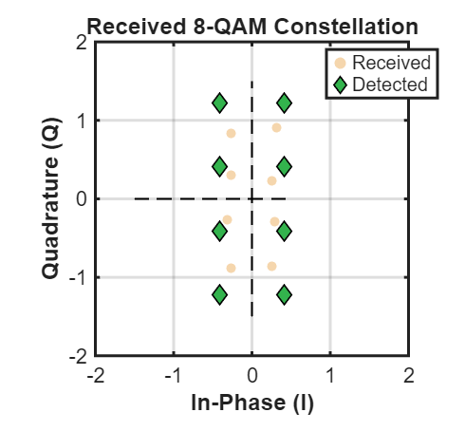

* *Plotting these* ***extracted values*** *gives the* ***noisy constellation diagram****, which shows how* ***noise pushes points away*** *from their* ***ideal positions****.*
* *With* ***low noise****,* ***constellation points cluster tightly*** *around their* ***ideal coordinates.***
* *With* ***high noise****, the* ***clusters spread*** *and may* ***overlap – increasing symbol errors.***
  1. ***Importance of the AWGN Channel in the Project***

*Including* ***AWGN*** *is critical for two reasons:*

1. *It* ***prepares*** *the signal for the* ***receiver***
2. *It allows evaluation of* ***8-QAM robustness***

*By comparing constellation plots at different* ***SNR levels****, we gain insight into how* ***resilient*** *the* ***modulation scheme*** *is under* ***noise****.*

*Overall, the* ***AWGN channel*** *transforms the transmitter from a* ***purely theoretical system*** *into a* ***realistic communication model.***

1. **MATLAB Transmitted and Noisy Constellations**
   1. ***Ideal (Noise-Free) Constellation***

*Before* ***adding noise****, the* ***ideal 8-QAM constellation*** *is plotted using the* ***normalized (I, Q) values.*** *The ideal constellation:*

* *Shows* ***8 distinct points****,*
* *Arranged in* ***two vertical columns***
* *With* ***equal spacing*** *along* ***both I and Q axes****,*
* *And* ***normalized*** *to* ***unit average energy***

*This clean constellation provides a reference for evaluating how* ***noise affects the signal****. Every* ***three bits map*** *to exactly* ***one constellation point****, confirming* ***correct modulation****.*

* 1. ***Modulated Waveform Inspection***

*The* ***modulated passband waveform*** *generated from:*



*Produces:*

* ***Smooth****,* ***continuous sinusoidal oscillations****,*
* ***Amplitude*** *variations depending on the* ***I*** *and* ***Q symbol****,*
* *And transitions at* ***each symbol boundary***

*This reflects how* ***real communication systems*** *transmit* ***symbols*** *through* ***analog waveforms*** *rather than as* ***discrete digital points.***

*Additionally:*

* *Higher* ***I*** *or* ***Q*** *values create* ***higher-amplitude oscillations***
* ***Symbol transitions*** *cause* ***shifts*** *in* ***phase*** *or* ***amplitude***
* *The* ***waveform*** *matches* ***theoretical expectations*** *for* ***QAM modulation***
  1. ***Effects of AWGN on Constellation***

*With* ***noise added****, constellation diagrams reveal:*

***Low SNR (e.g., 0–5 dB)***

* *Points* ***spread*** *widely.*
* *Clusters begin to* ***overlap.***
* *Symbol decision boundaries become* ***ambiguous.***
* ***Higher BER (Bit Error Rate)*** *is expected.*

***Moderate SNR (5–15 dB)***

* *Constellation clusters* ***tighten****.*
* *Symbols are more* ***distinguishable.***
* *Most* ***correct detections*** *are possible with* ***simple demodulation.***

***High SNR (15–any higher value dB)***

* *Constellation closely resembles the* ***ideal version.***
* *Only minor displacement due to* ***Gaussian noise****.*
* *Symbol decisions become* ***highly reliable****.*

*These patterns perfectly match the* ***textbook behavior of QAM modulation*** *under* ***AWGN.***

* 1. ***Effects of Attenuation on Constellation***

***Low Attenuation***

* ***Factor****: $0.7≤α≤1.0$*
* *Only slight* ***amplitude reduction***
* *Constellation* ***shrinks*** *only a little*
* *High SNR, low* ***Bit Error Rate (BER)***

***Moderate Attenuation***

* ***Factor: $0.3≤α<0.7$***
* *Clear* ***reduction*** *in symbol amplitude*
* *Constellation points move* ***toward the origin***
* *SNR* ***decreases*** *noticeably*
* ***Medium Bit Error Rate*** *(BER)*

***High Attenuation***

* ***Factor: $α<0.3$***
* *Signal becomes* ***very weak***
* *Constellation is* ***tightly compressed***
* *Noise dominates →* ***high Bit Error Rate (BER)***
* *Can approach* ***noise floor (lowest noise level)***
  1. ***Summary of Findings***

*The* ***MATLAB*** *Message (User Data) was* ***transmitted successfully:***

* *Accepts arbitrary* ***bit sequences****,*
* *Maps them to a* ***2-D 8-QAM constellation****,*
* ***Normalizes*** *symbol energy,*
* ***Modulates*** *the waveform using* ***orthogonal carriers****,*
* *Produces a realistic* ***passband signal****,*
* *And models channel noise using* ***AWGN****.*

*The simulation outcomes confirm both* ***correct implementation*** *of* ***theoretical communication principles*** *and practical behavior under* ***real channel conditions.***

1. **Demodulation and ML (Maximum Likelihood Detection)**
   1. **Demodulation**

*When the* ***transmitted 8-QAM*** *symbols pass through the channel, they are affected by* ***Additive White Gaussian Noise (AWGN)****. This noise slightly changes the* ***In-phase (I)*** *and* ***Quadrature (Q)*** *components of* ***each symbol****. They still resemble the* ***original constellation points*** *but appear* ***scattered*** *around them because of the* ***noise****. In* ***digital communication systems****, this* ***scattering*** *is expected, and the* ***receiver*** *must correctly* ***identify each symbol*** *despite these changes*

***Demodulation*** *is basically extracting the* ***In-Phase(I)*** *and* ***Quadrature(Q)*** *components from the* ***received orthogonal carrier waves*** *(carrying the* ***noisy symbols****).*

*It is done using* ***matched filtering method (correlation)***

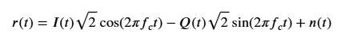

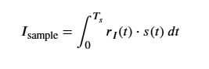

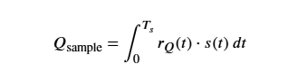

* 1. **Received Noisy Symbols**

*When the* ***transmitted complex QAM symbols $s(k)$*** *pass through the* ***AWGN channel****, the* ***received signal*** *(with* ***noisy symbols****) can be represented as:*

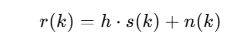

*Where:*

* $h$*= channel* ***attenuation factor***
* $s(k)$*= transmitted* ***8-QAM symbol***
* $n(k)$*= scaled* ***AWGN noise******(Gaussian distribution using SNR)***

Now the received **noisy symbols** don’t lie on the **ideal constellation points** instead now they are **spread** around **original constellation points.**

* 1. ***ML Detection Method***

**Maximum Likelihood (ML)** detection is a common method used in digital receivers. The idea is simple: the receiver chooses the constellation point that is closest to the received sample.

This works well because in an **AWGN channel** the most likely transmitted point is the one with the **smallest difference** from the **received symbol. ML detection** therefore **minimizes** the chances of choosing the **wrong symbol**.

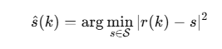

*Where:*

* $r(k)$*= received symbol*
* $S$*= set of all possible 8-QAM constellation points*
* $\hat{s}(k)$*= detected symbol*
  1. ***Euclidean distance detection***

*In* ***MATLAB*** *the receiver compares* ***each received symbol*** *with all eight* ***ideal 8-QAM points.*** *The Equation used here is:*

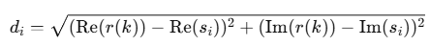

*The system finds the* ***smallest distance*** *and selects that* ***constellation index*** *as the* ***detected symbol****. This method matches how practical digital receivers* ***detect QAM signals****.*

*Figure*

*1*

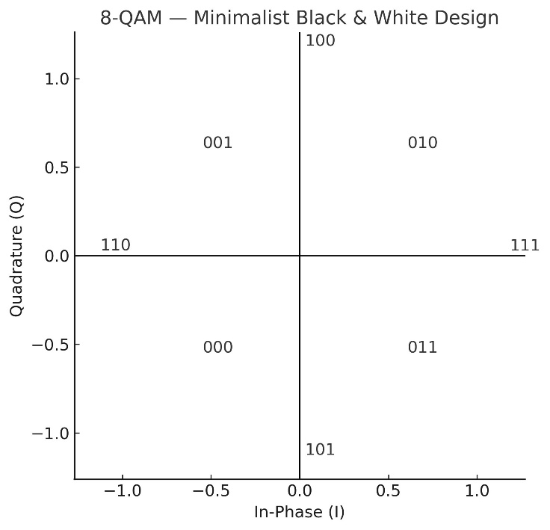

***Why Euclidean Distance Works***

*Since AWGN affects both* ***I*** *and* ***Q*** *with* ***Gaussian noise****, the best method for* ***optimal symbol recovery*** *is the* ***Euclidean distance****/* ***ML Detection Method****.*

* 1. ***Symbol De-Mapping***

*After identifying the closest point, the* ***receiver*** *converts that point back into the* ***original 3-bit****.*

*This stage is called* ***symbol******de-mapping****, and it turns the de****tected signal-space decisions*** *back into* ***digital data****. The mapping must match the* ***exact same lookup table*** *used in the* ***transmitter*** *for* ***accurate data transmission****.*

* 1. ***Bit Extraction***

Finally, all de**-mapped bit groups** are reshaped into a **single vector** so they can be compared with the **transmitted** **bits**. Any ext**ra padding bits added** earlier are **removed**. The receiver then evaluates **how many bits** were **recovered correctly**, which is used to calculate the **Bit Error Rate (BER).**

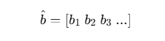

* 1. ***Summary***

*The decision stage of* ***converting detected constellation*** *points back to their respective* ***3-bit labels****. The decoded bits were reshaped to form a* ***serial bit stream.*** *Any* ***padding was removed****, and the* ***bit sequence*** *was prepared for comparison with the* ***original data transmitted****. This task focused on the final steps of* ***symbol de-mapping*** *and preparation of the* ***recovered bit sequence*** *for* ***performance evaluation****.*

1. **BER Detection and its Variations**

**Bit Error Rate** basically **quantifies** how **reliable** the **transmission system** is by comparing the **original bitstream** to the **noisy bitstream** at the **receiver’s side.**

It tells us how **less effective** (bit sequences lost) the **transmission system** is.

**BER** helps in **analyzing** the **transmission** with a broader view since it gives us a numerical value for error that has occurred.

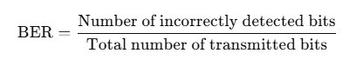

*If the transmitted bit sequence is $b$**and the detected sequence is $\hat{b}$**, then:*

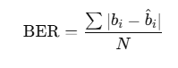

*Where:*

* $N$*=* ***total number of bits***
* $b_{i}$*=* ***transmitted bit***
* ${\hat{b}}_{i}$***= detected bit***

*A lower* ***BER*** *implies a* ***better*** *and* ***more reliable communication system.***

1. **MATLAB Code Explanation**

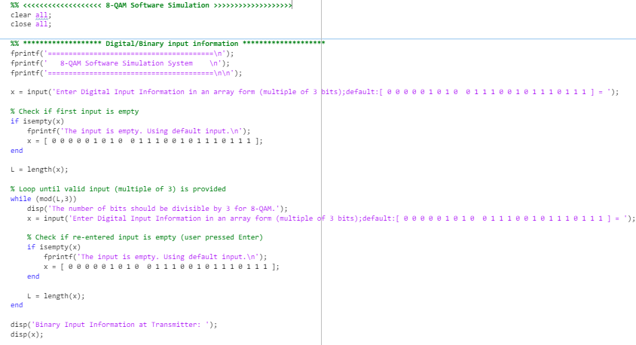

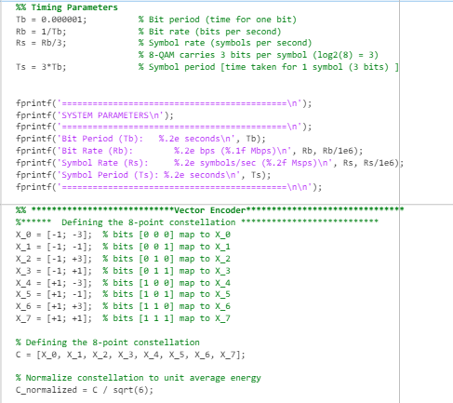

* User provides the **inputs manually** and the **timing parameters** are **initialized**.
* **Constellations** are assigned for an **8-QAM Communication System**.
* Each **Constellations** are then **normalized** by the **normalization factor** that is by the **square root** of **Es** to maintain the **energy balance** between **each constellation.**

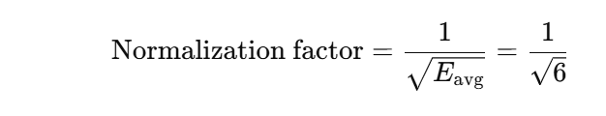

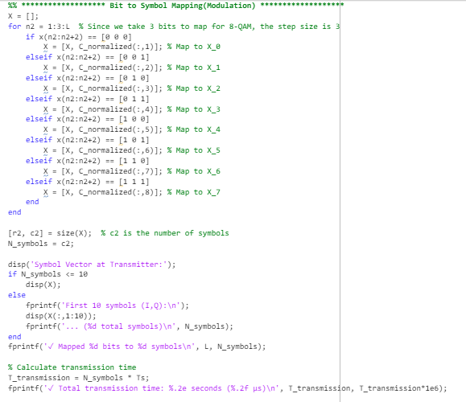

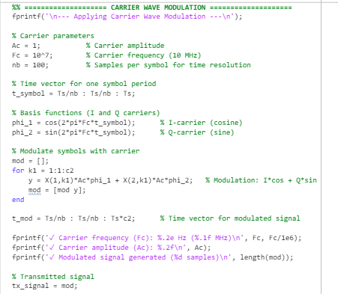

* In **Modulation** each **3-bit groups** are mapped to the **constellations** to form **symbols**. These **symbols** are then **channeled through high frequency orthogonal carriers (with 2 basis functions for the In-Phase and Quadrature Components).** Basically, **baseband signals** are converted to **passband signals**.
* But since this a **MATLAB** only **digital communication system** we will only be able to get the **theoretical approximation** of the **System**.

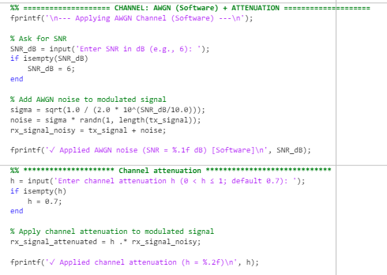

* Here the **AWGN (Additive White Gaussian Noise)** is added to the **transmitted signal.**
* The **AWGN** we are using here is not a **standard Gaussian Distribution** but a **scaled Gaussian Distribution** that **varies with SNR** **(Signal to noise ratio; unit is decibels represented as dB)** values.
* Here we are also simulating the **attenuation** that can be caused using the **attenuation factor** value inputed by the user.

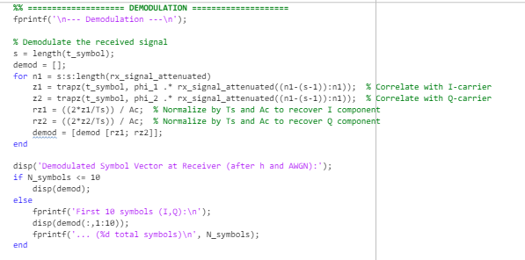

* Here we are **retrieving** the **noisy symbols** from the **Carrier Wave** using the **trapezoidal function** that is basically the **matched filtering method (integration).**
* After retrieving the **I** and **Q** values for the **noisy symbols**, they are then **mapped** back to the **original constellations**.

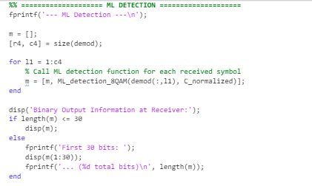

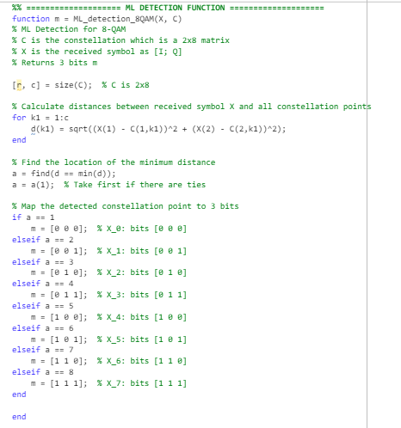

* Using the **ML (Maximum Likelihood) Detection** method the **received noisy symbols** are **mapped back** to the **original constellation**.
* A new **function** named **ML_detection_8QAM** is created that takes in **2 parameters** the **received symbols** and the **original constellations** and then **returns the index** of the **constellation point** detected as the **closest one** to the **received symbol**.

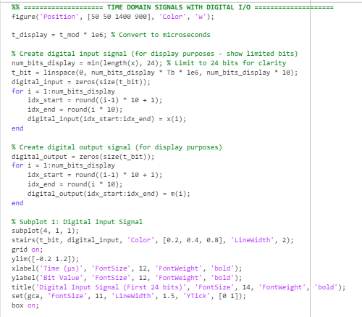

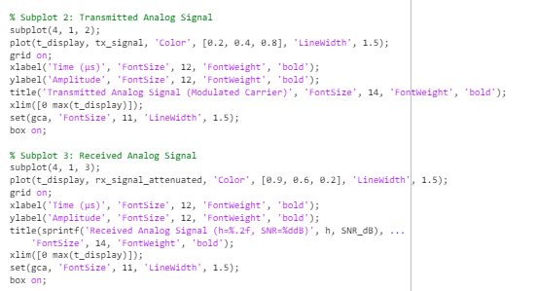

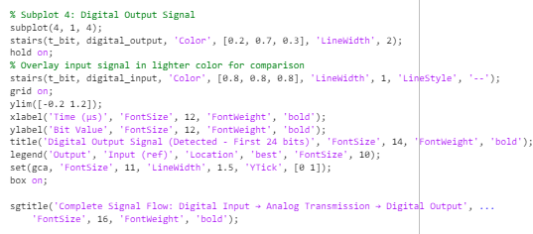

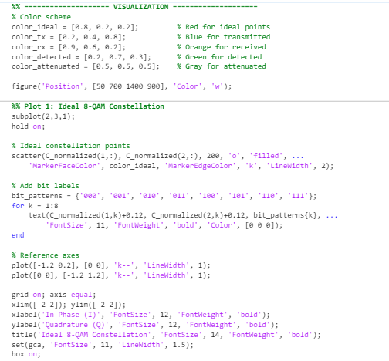

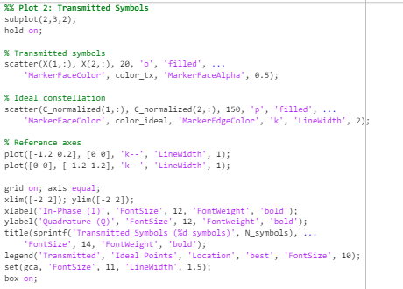

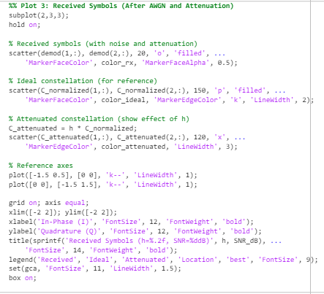

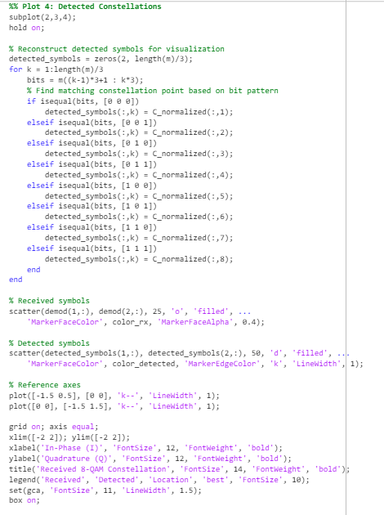

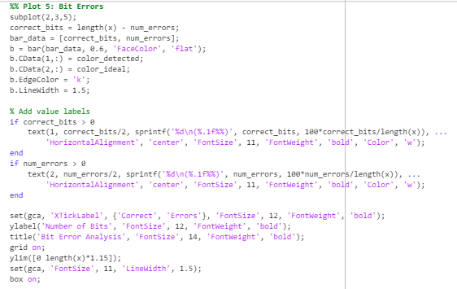

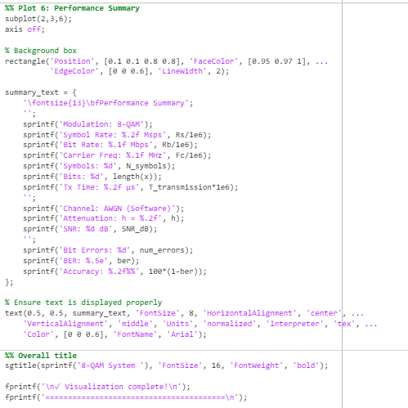

* The above shown code is for the **plots diagrams** that can help us understand using **visual representations**.
* **8 plots** in total are plotted for the **8-QAM System** which are as below:
  + **Digital Input signal**
  + **Transmitted Analog Signal**
  + **Received Analog Signal**
  + **Digital Output Signal**
  + **Ideal 8-QAM Constellation**
  + **Transmitted Symbols**
  + **Received Symbols *(After AWGN and Attenuation)***
  + **Detected Constellation**

1. **Results and Discussion**

**ORIGINAL OUTPUT**

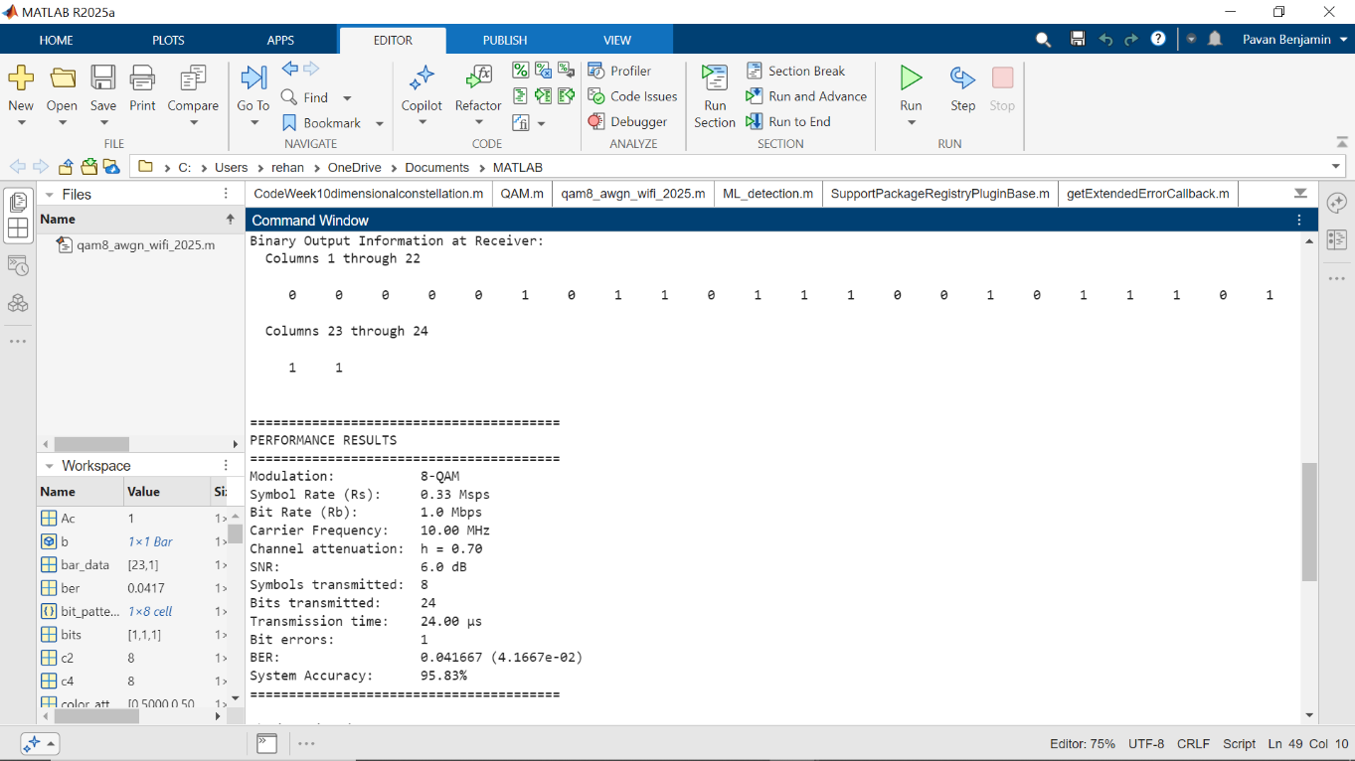

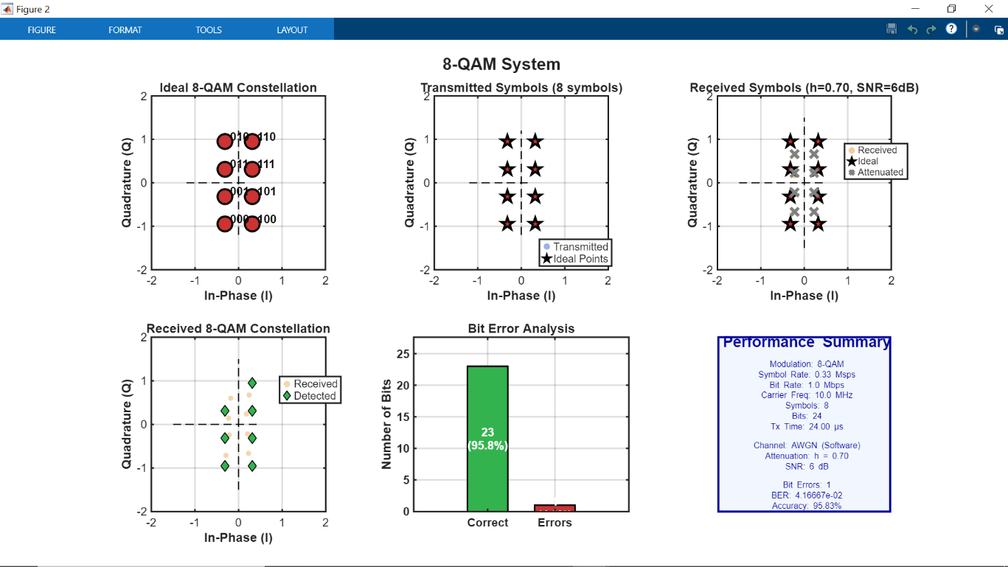

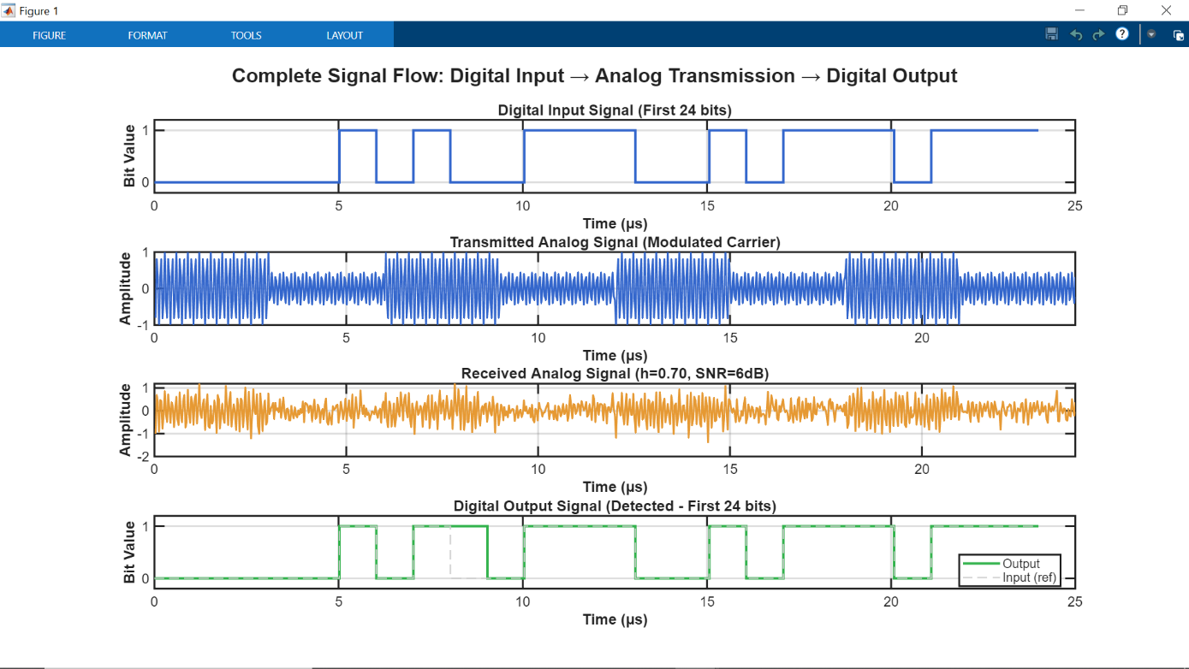

**SNR Decreased**

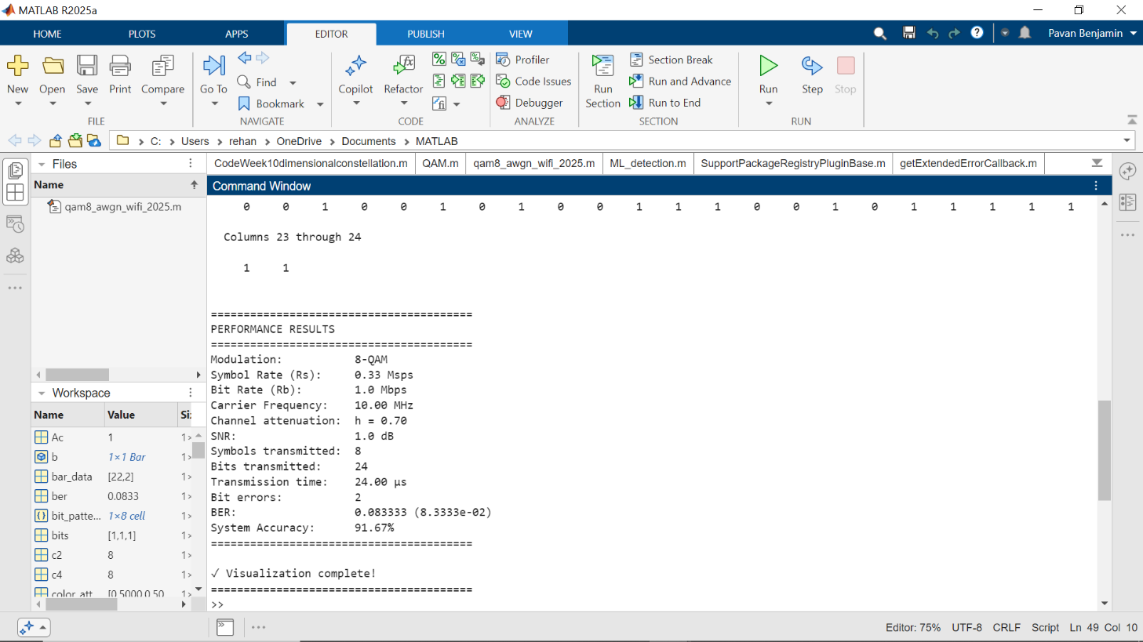

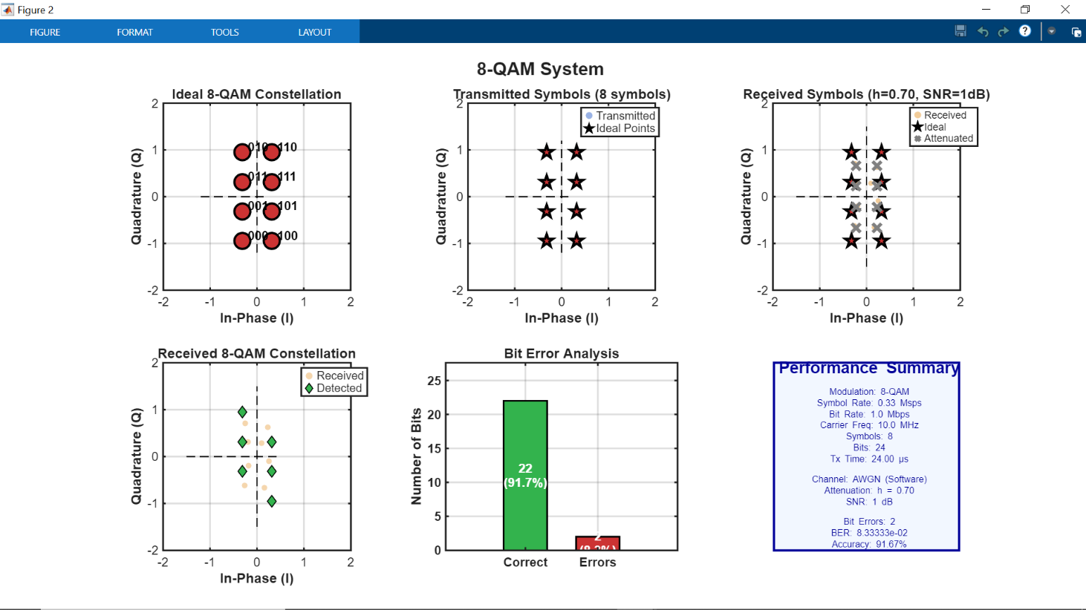

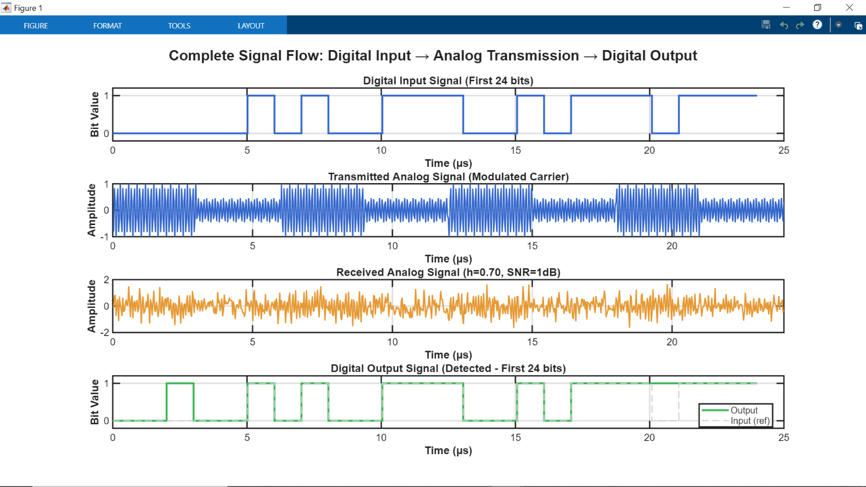

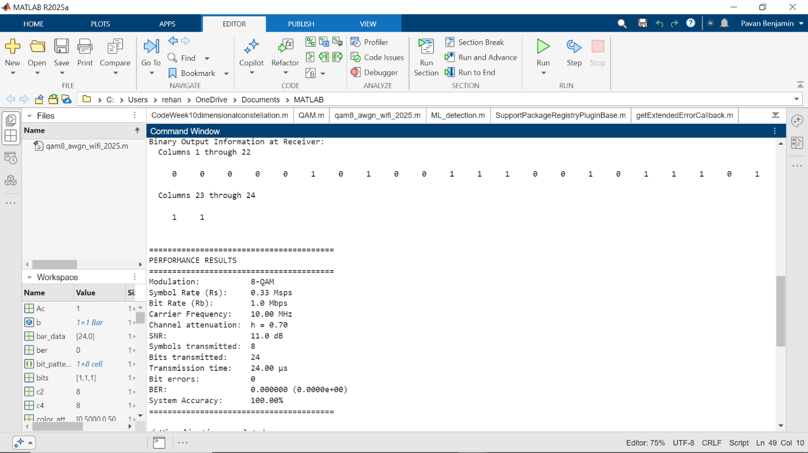**SNR Increased**

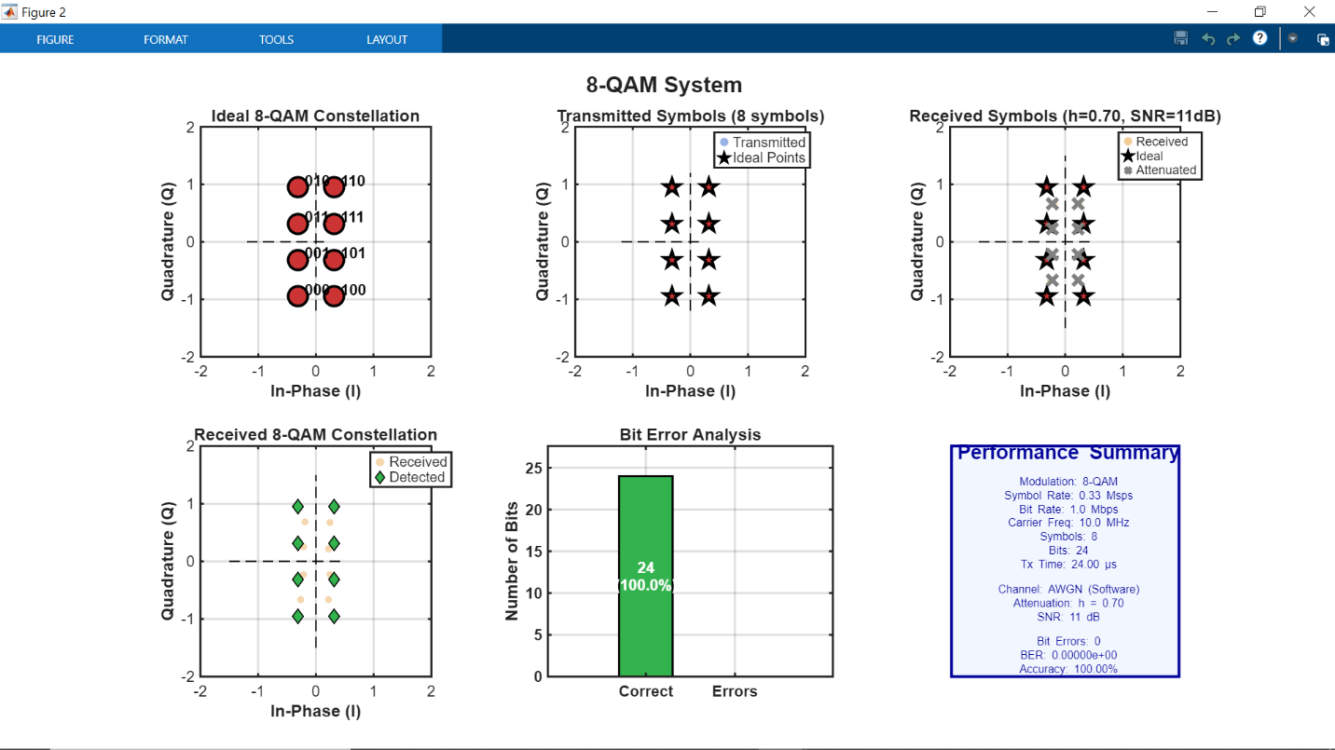

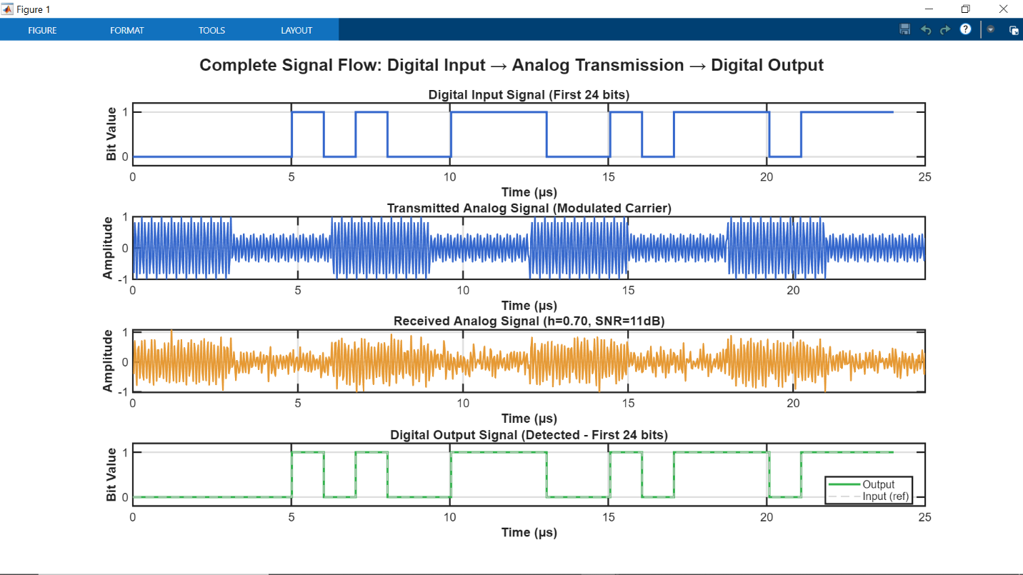

* Here we can see that when **SNR increases accuracy increases** and **vice versa when it decreases.**
* **NOTE:** 
  + Here **default SNR value is set to 6** which is lower than the def**ault SNR value** of the **Hardware Implementation** because since there is no **real** **transmission** in this **software implementation** the, **BER (Bit Error Rate)** compared to the **Hardware Implementation** is low.
  + So, by testing out **various SNR values (using trial and error method)** we concluded that at **6dB (decibels)** is the **avg value** at which **Accuracy** of the system can be **100% or lower**.

**Attenuation Factor Increased**

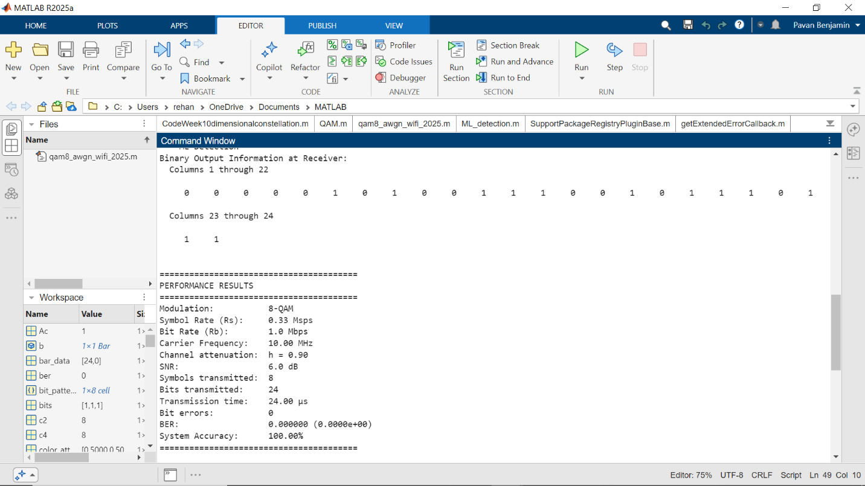

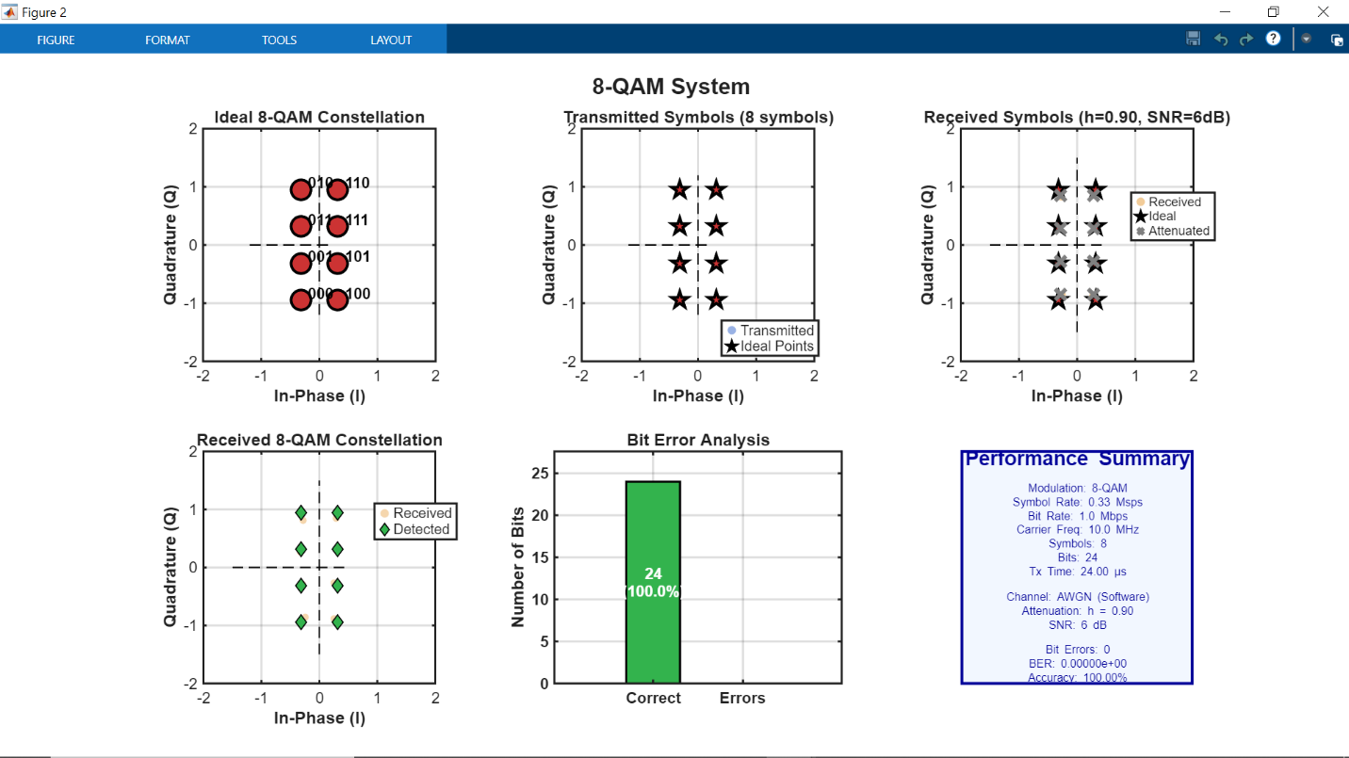

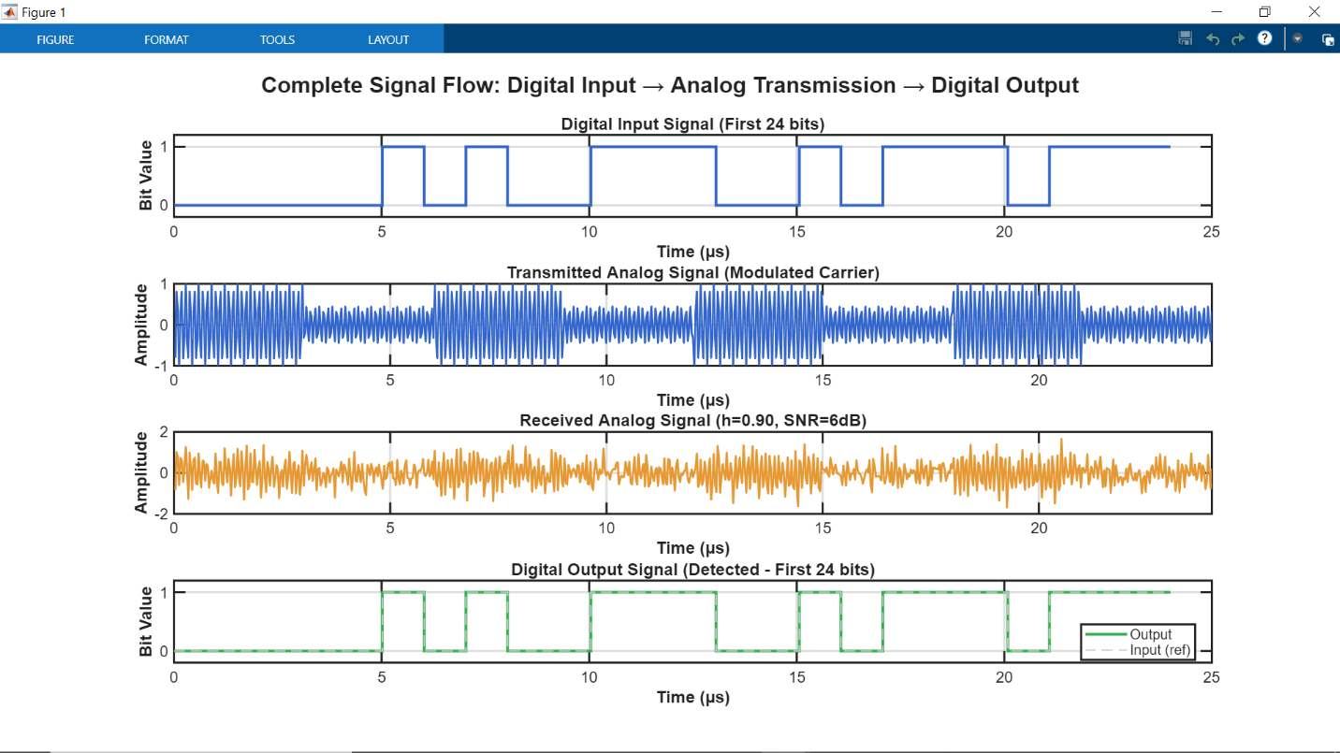

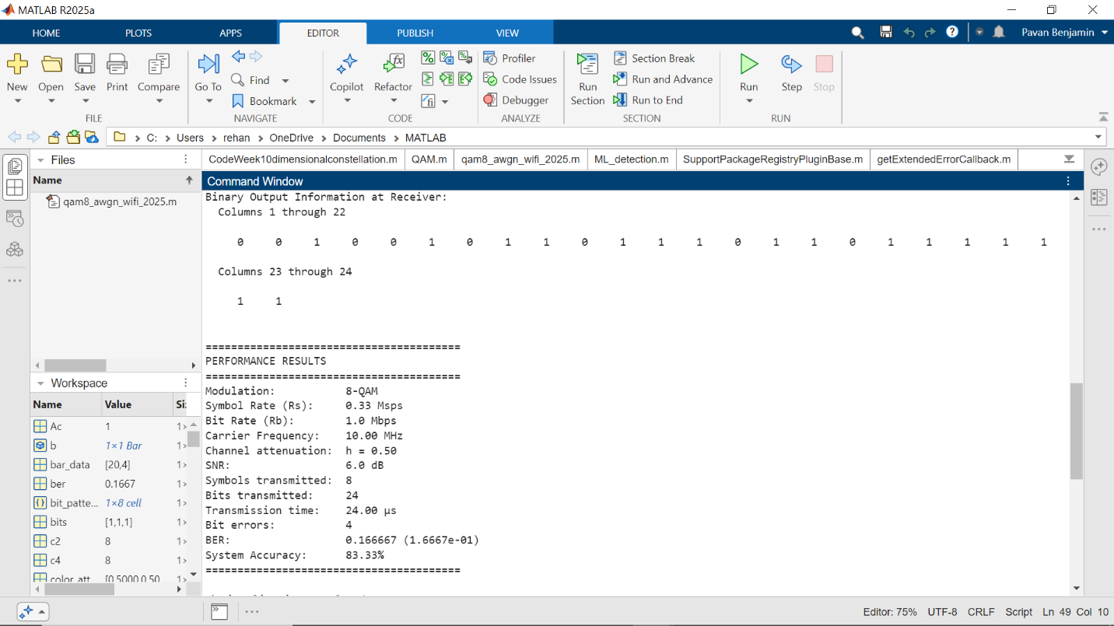***Attenuation Factor Decreased***

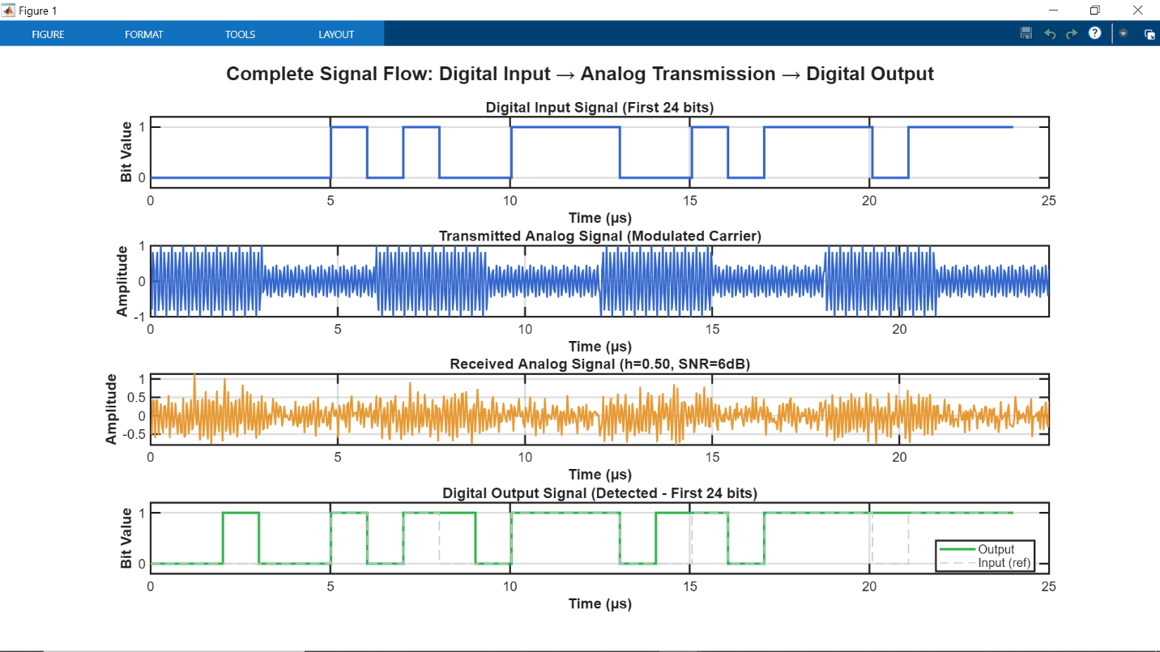

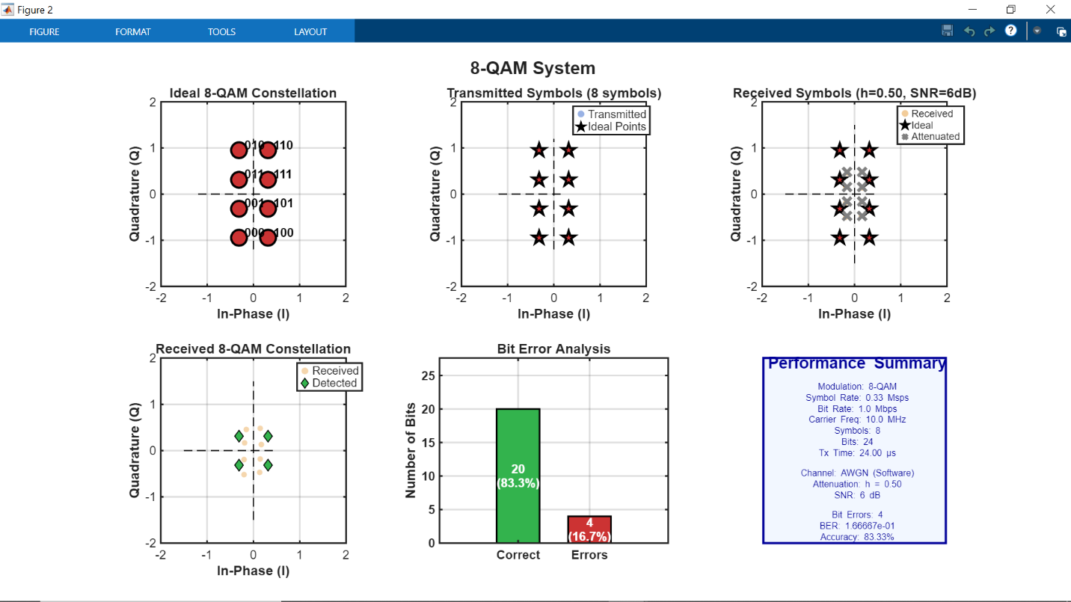

* Here we can see that when **attenuation factor is decreased**, **BER (Bit Error Rate) increases and accuracy plummets.** **Vice versa** is the case when **attenuation factor increases.**
* **Note:**
  + Changes when **Attenuation** and **SNR** values are varied is exactly like the **Hardware Implementation** with the only difference that their **default values are different**. The idea here is basically the same.

1. **Software (MATLAB only) and Hardware (MATLAB +Python using Raspberry Pi) Compared Performance Analysis**

**Performance Analysis** tells us how effective our **transmission system** basically is.

It gives us an understanding of the **effectiveness of our Transmission System.**

***Software-only model (MATLAB)****:*

* *Entire system is* ***simulated within MATLAB software****.*
* *Uses an ideal* ***Additive White Gaussian Noise (AWGN)*** *channel.*
* *This simulation represents an* ***ideal*** *and* ***theoretical communication system****.*
* *Since* ***Noise addition*** *is done within* ***MATLAB*** *itself, we can get our* ***ideal expected output.***
* *Due to the* ***model being ideal****, the system will have* ***comparatively lower BER.***

***Hardware-like model:***

* *System is* ***implemented*** *using* ***MATLAB and python (in Raspberry Pi)*** *where python is used as an* ***AWGN emulator****.*
* ***AWGN*** *is generated and applied using* ***real hardware****.*
* *This simulation represents a more* ***practical*** *and* ***realistic communication system.***
* Since the **Hardware model** involves **actual transmission** noise can be affected due to **hardware processing** and **data transmission**.
* This model will have comparatively **higher BER**.

## **Summary**

The **MATLAB-only implementation** basically represents an **ideal communication system.** It uses a **controlled AWGN channel** with perfect **synchronization** and **no hardware effects**, resulting in **lower BER** and performance close to **theoretical expectations**. This model is mainly used for **theoretical analysis**. This system is **less effective** when it comes to practicality since it’s modeled based on an **ideal system.**

On the other hand, the **MATLAB–Raspberry Pi** **implementation** includes **actual data processing**, where **noise** and **channel effects** are applied using **real hardware (Raspberry Pi).** This introduces practical issues such as **attenuation**, **timing delays**, and **data transfer imperfections**, leading to **higher BER.** Although performance is reduced compared to the **MATLAB-only model**, this approach provides a more **realistic evaluation of system behavior**.

Overall, the **MATLAB-only model** is suitable for understanding the **ideal** **Communication System**, while the **MATLAB–Raspberry Pi implementation** is a good example for **assessing real-world performance** and **practical feasibility**.

1. **Conclusion**

*In this project an 8****-QAM Communication System*** *was developed where we showed both* ***Software*** *as well as* ***Hardware Implementation****.*

*We have* ***analyzed*** *and* ***shown the differences*** *these systems have with each other since* ***software implementation*** *can give us a* ***theoretical*** *and* ***ideal understanding*** *of the system while* ***hardware implementation*** *provides a more practical approach.*

*Both implementations give us a detailed understanding of the* ***8-QAM System.***

*We have even* ***analyzed*** *the differences both systems each have when* ***attenuation and SNR values*** *are changed. Both* ***Attenuation [path-loss (measure of how much signal has been lost over the signal)]******and SNR [Signal to Noise ratio (in decibels: dB)]*** *play significant role in improving the performance of the* ***8-QAM System.***

*The plots provide us with an* ***understanding of the 8-QAM System****. It provides visual understanding of the* ***8-QAM Communication System****. It allows us to understand the Symbols and their* ***mapped Constellations****; also helps us understand the* ***BER (Bit Error Rate)*** *and its variation with* ***attenuation*** *and* ***SNR****.*

*Overall, the* ***8-QAM*** *is considered the most frequently used* ***Communication*** *method since it allows us to transmit* ***large no. of bits*** *over areas with* ***low SNR values****.*

*Some of the applications of the* ***8-QAM System*** *are mentioned below:*

* ***Wi-Fi*** *(IEEE 802.11 standards)*
* ***Mobile communication*** *and* ***Cellular systems (4G LTE and 5G)***
* ***Digital television broadcasting (DVB systems)***
* ***Microwave*** *and* ***point-to-point radio links***

1. **References**

Proakis, J.G. and Salehi, M., 2014. Digital Communications. 5th ed. New York: McGraw-Hill.

Prandoni, P. and Vetterli, M., 2008. Signal processing for communications. EPFL press.

Peebles Jr, P.Z., 1987. Digital communication systems. Englewood Cliffs.

Nadal, L., Fàbrega, J.M., Vílchez, J. and Moreolo, M.S., 2015. Experimental analysis of 8-QAM constellations for adaptive optical OFDM systems. IEEE Photonics Technology Letters, 28(4), pp.445-448.

Singya, P.K., Shaik, P., Kumar, N., Bhatia, V. and Alouini, M.S., 2021. A survey on higher-order QAM constellations: Technical challenges, recent advances, and future trends. IEEE Open Journal of the Communications Society, 2, pp.617-655.

Singya, P.K., Shaik, P., Kumar, N., Bhatia, V. and Alouini, M.S., 2020. A survey on design and performance of higher-order QAM constellations. arXiv preprint arXiv:2004.14708.

Kishikawa, H., Uetai, M. and Goto, N., 2019. All-optical modulation format conversion between OOK, QPSK, and 8QAM. Journal of Lightwave Technology, 37(16), pp.3925-3931.

Gautschi, W., 1971. Attenuation factors in practical Fourier analysis. Numerische Mathematik, 18(5), pp.373-400.

Tandra, R. and Sahai, A., 2008. SNR walls for signal detection. IEEE Journal of selected topics in Signal Processing, 2(1), pp.4-17.

Omari, E.A. and Varghese, T., 2014. Signal to noise ratio comparisons for ultrasound attenuation slope estimation algorithms. Medical physics, 41(3), p.032902.

Pauluzzi, D.R. and Beaulieu, N.C., 2002. A comparison of SNR estimation techniques for the AWGN channel. IEEE Transactions on communications, 48(10), pp.1681-1691.

*Banavar, M.K., Tepedelenlioglu, C. and Spanias, A., 2012. Distributed SNR estimation with power constrained signaling over Gaussian multiple-access channels. IEEE Transactions on Signal Processing, 60(6), pp.3289-3294.*Vankka, J., Kosunen, M., Sanchis, I. and Halonen, K.A., 2000. A multicarrier QAM modulator. IEEE Transactions on Circuits and Systems II: Analog and Digital Signal Processing, 47(1), pp.1-10.

Tan, M. and Chen, W., 2011, September. Performance comparison and analysis of PSK and QAM. In 2011 7th International Conference on Wireless Communications, Networking and Mobile Computing (pp. 1-4). IEEE.

*Pasolini, G., Bazzi, A. and Zabini, F., 2017. A raspberry pi-based platform for signal processing education [sp education]. IEEE Signal Processing Magazine, 34(4), pp.151-158.Abood, A.M., Hussein, M.S., Faisal, Z.G. and Tawfiq, Z.H., 2021. Design and simulation of video monitoring structure over TCP/IP system using MATLAB. Indonesian Journal of Electrical Engineering and Computer Science, 24(3), pp.1840-1845.*

*Hassan, G.M., Hussien, N.M. and Mohialden, Y.M., 2023. Python tcp/ip libraries: A review. International Journal Papier Advance and Scientific Review, 4(2), pp.10-15.*

*Harris, C.R., Millman, K.J., Van Der Walt, S.J., Gommers, R., Virtanen, P., Cournapeau, D., Wieser, E., Taylor, J., Berg, S., Smith, N.J. and Kern, R., 2020. Array programming with NumPy. nature, 585(7825), pp.357-362.*

*Butkowski, Ł. and Karakurt, M., 2019. CO-SIMULATION OF HDL USING PYTHON AND MATLAB OVER TCL TCP/IP SOCKET IN XILINX VIVADO AND MODELSIM TOOLS.*

*POMYEN, S., 2015. SIGNAL AND IMAGE PROCESSING WITH MATLAB ON RASPBERRY PI PLATFORM. Examiner and topic approved by the Faculty Council of the Faculty of Computing and Electrical Engineering on, 4.*

***Referring to University Material***

PDE2113 University Lecture Notes (2024) 'Signal Processing and Communications Module'. Middlesex University.

PDE2113 Lab Template (2024) 'Modulation and demodulation with 2D constellation.

Middlesex University.

PDE2113 Module Team (2024) Report template for PDE2113 group project. Middlesex University.

***NOTE:*** Also referring to university materials provided in MDX My Learning

1. ***Personal Overview***
   1. ***Pavan Benjamin Philip (M01036984)***

This project has helped me gain invaluable insights into the practical implementation of digital communication systems. By facing numerous challenges, I was able to understand the technical aspects of an 8-QAM Communication System. By working on this system, I was able to understand the practicality of the theoretical concepts I learned during lectures, thereby strengthening my understanding of how modern wireless communication networks operate.

My major contribution to this project was basically developing and implementing the hardware integration between MATLAB and Raspberry Pi 5. This hybrid architecture was encouraged since MATLAB is designed for x86-64 processors and cannot natively run on an ARM-based Raspberry Pi. Therefore, using Python (running in Raspberry Pi) I designed a TCP/IP socket-based communication system that can transmit data between MATLAB and Raspberry Pi seamlessly. Establishing this connection took a lot of effort since there can be transmissions issues like cases where the data transmitted data was not sent in the correct format. To be honest the connection was more challenging than what I had anticipated. I had faced numerous issues, such as network configuration errors, incorrect prompt for SSH protocol implementation for secure communication, and IP Address, port related issues between the two systems. After some continuous research and troubleshooting, I was able to successfully establish a stable and secure connection on Port 5000, which allowed real-time transmission of modulated symbols from MATLAB to the Raspberry Pi and back.

On Raspberry Pi 5, I developed a Python file (named awgn_server.py) that would act as my server for the hardware AWGN (Additive White Gaussian Noise) channel emulator. This server receives modulated 8-QAM symbols along with the user-specified SNR value, calculates the appropriate noise variance using the formula:

σ² = Es/(2·10^(SNR/10)),

and then adds scaled Gaussian noise to simulate a realistic channel to meet the required conditions. Implementing this in hardware helped me gain great amount of insight regarding its real-world application as the results, the hardware implementation gives include the error that occur during transmission as well. Through these we are very well able to analyze the causes of these errors thereby helping us create secure channels which can transmit data safely and minimize these errors. It also helped me understand how noise affects the original signal during transmission. The NumPy library, which is an array-based library, is essential for generating statistically accurate Gaussian noise samples that match theoretical AWGN characteristics. This hardware implementation provided a more realistic simulation compared to the purely MATLAB-based approach, as it introduces actual processing delays and hardware-induced variations (transmission errors) that occur in real communication systems.

Throughout the project, I also worked extensively in analyzing the system’s performance analysis. By varying SNR values and attenuation factors, I observed fascinating patterns in the system's behavior. I was able to figure out that as SNR increases, the Bit Error Rate (BER) decreases significantly, and the received constellation points cluster more tightly around their ideal positions. Also, when I reduced the attenuation factor below 0.7, I was initially confused to see BER increasing. This made me realize about the logarithmic relationship between attenuation (path loss) and attenuation factor – a counterintuitive but important concept in communication systems. Similarly, by testing different attenuation values, they revealed how signal strength degradation directly impacts system accuracy, with lower attenuation factors causing constellation points to compress toward the origin thereby dramatically increasing error rates.

I faced multiple technical challenges, some of which took a lot of time and effort in troubleshooting. Beyond the connection issues, I faced difficulties with the Raspberry Pi hardware itself, including OS installation problems that caused the Raspberry Pi to stay blank, loose LED screen connections resulting in display issues, and timeout issues between MATLAB and Python. Each problem required careful troubleshooting and debugging. As each problem was resolved it was 1 step closer to receiving a correct output. These experiences taught me how to stay calm and patient during the debugging process and how troubleshooting must be conducted systematically in order to get the correct result.

This project has helped me significantly upgrade my technical skillset in digital signal processing, network programming, hardware-software integration, and performance analysis. More importantly, it has deepened my understanding of how theoretical communication principles translate into practical systems. The experience of seeing bits successfully transmitted, modulated, corrupted by noise, and accurately recovered through Maximum Likelihood detection was really satisfying indeed. This project has piqued my interest in communication systems and embedded hardware, and I now have a much clearer picture of how Wi-Fi, cellular networks, and modern digital communication systems operate at a fundamental level. Moving forward, I will be able to apply these concepts and gain further insights into the core of digital communication systems.

* 1. **Karl Enzo Cruz (M01039769)**

*In my understanding, this project involves design and simulation of a full digital communication system, including generation of data at the transmitter and recovery of the signal at the receiver. The report outlines the process involved in binary data packetizing them into symbols, encoding them in an 8-QAM constellation and modulating them onto a carrier wave to transmit them with maximum efficiency. It additionally discusses the implications of the channel and the process of demodulation and detection of the original bitstream. All this is done using MATLAB simulation to visualize the signals and ensure proper system operation.*

*One of the challenges I encountered was that the little mistakes during the initial steps, e.g. mapping of symbols, may affect the system as a whole. These problems forced me to debug more and then I realized how all the blocks are interconnected and the overall performance of the system relies on proper implementation at each phase.*

* 1. **Adam Nosseir (M00972954)**

During this project I learned how an 8-QAM communication system works step by step, from sending data to receiving it. I understood how bits are sent through a channel and then recovered at the receiver. Using MATLAB made everything clearer because I could actually see what was happening.

I also learned how Maximum Likelihood detection works by choosing the closest symbol point, and how this simple idea is very important in digital communication. Calculating the Bit Error Rate helped me see how system performance is measured and how even small noise can cause errors. Some parts were difficult at first, especially understanding Euclidean distance and making sure the MATLAB code worked correctly. Comparing simulation results with hardware results was also challenging because real systems have extra problems like noise and signal loss. Overall, these challenges helped me understand real communication systems better and made the learning more practical and meaningful.

1. **Appendix**

## NOTE: Clearer and highly commented MATLAB code for the Hardware and Software only Implementation are displayed in the MATLAB files attached with this report

I have only used General comments for the snippets pasted in this document, since by adding comments the code size increases thereby making it unclear when taking screenshots.

Detailed Comments are in the other MATLAB Files attached with this report.